

UNIVERSITY OF GHANA

COLLEGE OF BASIC AND APPLIED SCIENCE

TIMETABLE MANAGEMENT SYSTEM

BY

PAUL ODARTEY

10977321

THIS IS A PROJECT SUBMITTED TO THE DEPARTMENT OF COMPUTER SCIENCE, UNIVERSITY OF GHANA, IN PARTIAL FULFILLMENT OF THE REQUIREMENTS FOR THE AWARD OF A BACHELOR OF SCIENCE DEGREE IN INFORMATION TECHNOLOGY.

DEPARTMENT OF COMPUTER SCIENCE

DECEMBER 2025

**TABLE OF CONTENT**

***TABLE OF CONTENT……………………………………………………………………………………………………………………………..………….…………..4***

***DECLARATION……………………………………………………………………………………………………………………………………………………***…………***7***

***ACKNOWLEDGMENT***……………………………………………………………………………………………………………………………………………............***8***

***DEDICATION……………………………………………………………………………………………………………………………………………………………….9***

***CHAPTER 1………………………………………………………………………………………………………………………………………………………….……***..***10***

**INTRODUCTION…………………………………………………………………………………………………………………………………………**…………**10**

Background of Study…………………………………………………………………………………………………………………………..……………..**10**

Academic Scheduling Challenges………………………………………………………………………………………………………………………..**10**

Technology in Education Management………………………………………………………………………………………………………………**11**

Role-Based Access Control Systems…………………………………………………………………………………………………………………….**11**

Problem Statement…………………………………………………………………………………………………………………………………………….**12**

Objectives of the Study……………………………………………………………………………………………………………………………………...**12**

Scope of the Study……………………………………………………………………………………………………………………………………………..**13**

Justification of the Study…………………………………………………………………………………………………………………………………….**13**

Conclusion………………………………………………………………………………………………………………………………………………………….**14**

***CHAPTER 2*** ***15***

**LITERATURE REVIEW**…………………………………………………………………………………………………………………………………………………**15**

Introduction……………………………………………………………………………………………………………………………………………………….**15**

Timetabling Algorithms and Educational Management Systems………………………………………………………………………..**16**

Database Design and System Architecture………………………………………………………………………………………………………….**17**

User Interface Design and Security Considerations……………………………………………………………………………………………..**18**

Conclusion………………………………………………………………………………………………………………………………………………………….**19**

***CHAPTER 3*** ***24***

**METHODOLOGY: MODELING AND DESIGN**………………………………………………………………………………………………………………**24**

Introduction……………………………………………………………………………………………………………………………………………………….**24**

Models……………………………………………………………………………………………………………………………………………………………….**25**

Designs……………………………………………………………………………………………………………………………………………………………….**26**

3.2.1 Databases……………………………………………………………………………………………………………………………………………**26**

3.2.2 Application Interfaces…………………………………………………………………………………………………………………………**27**

3.2.3 Report…………………………………………………………………………………………………………………………………………………**28**

3.2.4 Data Validation……………………………………………………………………………………………………………………………………**29**

Security………………………………………………………………………………………………………………………………………………………………**30**

Conclusion………………………………………………………………………………………………………………………………………………………….**31**

***CHAPTER 4*** ***32***

**SYSTEM IMPLEMENTATION**……………………………………………………………………………………………………………………………………..**32**

Introduction……………………………………………………………………………………………………………………………………………………….**32**

4.1 Hardware and Software Requirement………………………………………………………………………………………………………….**33**

4.2 System Installation……………………………………………………………………………………………………………………………………….**34**

4.3 Software Testing……………………………………………………………………………………………………………………………………..**35**

4.3.1 Functional testing…………………………………………………………………………………………………………………………………**35**

4.3.2 Performance testing…………………………………………………………………………………………………………………………….**36**

4.3.3 Stress testing………………………………………………………………………………………………………………………………………..**37**

4.3.4 Structure testing…………………………………………………………………………………………………………………………………..**38**

4.4 Debugging…………………………………………………………………………………………………………………………………………………….**39**

4.5 USER Training……………………………………………………………………………………………………………………………………………….**40**

4.6 Maintenance………………………………………………………………………………………………………………………………………………..**41**

4.7 System Documentation………………………………………………………………………………………………………………………………..**42**

4.8 Conclusion……………………………………………………………………………………………………………………………………………………**43**

***CHAPTER 5*** ***44***

**DISCUSSION, SUMMARY AND CONCLUSION**……………………………………………………………………………………………………………..**44**

Introduction………………………………………………………………………………………………………………………………………..**44**

5.1 Discussion of findings……………………………………………………………………………………………………………………………….**45**

5.2 Problems Encountered……………………………………………………………………………………………………………………………..**46**

5.3 Summary……………………………………………………………………………………………………………………………………………………**47**

5.4 Conclusion………………………………………………………………………………………………………………………………………………….**48**

***REFERENCES***……………………………………………………………………………………………………………………………………………………………………***49***

***APPENDICES***……………………………………………………………………………………………………………………………………………………………………***5***

**DECLARATION**

I, **PAUL ODARTEY,** hereby declare that this project is a result of my own research, except for the references made and is not in any way a reproduction of any existing projects. This project is purely for academic purposes and not for monetary gains.

……………………………..

Prof. Winifred Yaokumah

(Supervisor)

……………………………..

Paul Odartey

(Student)

**ACKNOWLEDGEMENT**

I would like to express my sincere gratitude to the Almighty God for His guidance and protection throughout this academic journey. My heartfelt appreciation goes to my supervisor, Prof. Winifred Yaokumah, for her invaluable guidance, patience, and constructive feedback that shaped this project from conception to completion.

I am deeply grateful to the Department of Computer Science, University of Ghana, for providing the conducive academic environment and resources necessary for this research. Special thanks to all the lecturers who have contributed to my academic growth throughout my undergraduate studies.

My profound appreciation goes to my family for their unwavering support, encouragement, and sacrifice throughout my academic pursuit. Their belief in my abilities has been a constant source of motivation.

I also acknowledge my colleagues and friends who provided technical assistance, moral support, and valuable insights during the development of this project. Their contributions, both direct and indirect, have been instrumental to the successful completion of this work.

Finally, I appreciate all the academic institutions and organizations whose scheduling challenges inspired this research and provided the real-world context for developing this timetable management solution.

**DEDICATION**

This project is dedicated to my beloved family, whose love, support, and sacrifices have made this achievement possible. To my parents, who instilled in me the value of education and perseverance, and to all educators who work tirelessly to manage academic schedules - may this system serve to ease their administrative burden and enhance educational delivery.

**CHAPTER 1**

**INTRODUCTION**

1. **Background of Study**

Academic scheduling represents one of the most complex administrative challenges facing educational institutions worldwide. The process of creating and managing timetables involves coordinating multiple variables including faculty availability, classroom resources, subject requirements, and student enrollment patterns. Traditional manual scheduling methods have proven inadequate for modern educational institutions, which require dynamic, efficient, and conflict-free schedule management systems.

The evolution of information technology has transformed various aspects of educational administration, yet many institutions continue to struggle with outdated scheduling practices. The complexity of academic scheduling increases exponentially with the size of the institution, number of courses offered, and the variety of constraints that must be satisfied. This has created a pressing need for automated, intelligent scheduling systems that can handle the intricate requirements of modern academic environments.

The Timetable Management System represents a comprehensive solution designed to address the multifaceted challenges of academic scheduling. This web-based application leverages modern software engineering principles to provide a robust, scalable, and user-friendly platform for managing academic schedules across different user roles and departments.

1. **Academic Scheduling Challenges**

* Educational institutions face numerous challenges in creating and managing academic schedules. The traditional approach to timetable creation involves manual coordination between various stakeholders, including academic coordinators, faculty members, and administrative staff. This process is not only time-consuming but also prone to errors, conflicts, and inefficiencies.
* The primary challenges in academic scheduling include resource allocation conflicts, where multiple classes compete for the same classroom or faculty member at identical time slots. Faculty scheduling presents another significant challenge, as instructors may have varying availability, teaching loads, and subject specializations that must be carefully coordinated. Additionally, institutions must consider classroom capacity constraints, equipment requirements, and the physical distribution of facilities across campus.
* Student enrollment patterns add another layer of complexity to the scheduling process. Different programs may have varying requirements, prerequisite courses, and semester structures that must be accommodated within the overall institutional schedule. The need to minimize conflicts in student schedules while maximizing resource utilization creates a complex optimization problem that traditional manual methods struggle to address effectively.
* Furthermore, academic institutions operate within dynamic environments where changes are frequent and often require immediate schedule adjustments. Faculty illnesses, room maintenance, special events, and curriculum modifications all necessitate rapid schedule modifications that can cascade throughout the entire timetable structure.

1. **Technology in Education Management**

* The integration of technology in educational management has revolutionized how institutions handle administrative processes. Modern educational institutions increasingly rely on comprehensive management systems to streamline operations, improve efficiency, and enhance the overall educational experience. These systems encompass various aspects of institutional management, including student information systems, learning management platforms, and administrative tools.
* Timetable management systems represent a specialized category of educational technology designed specifically to address scheduling challenges. These systems leverage computational algorithms, database management, and user interface design to provide automated solutions for schedule creation, conflict detection, and resource optimization. The adoption of such systems has shown significant improvements in administrative efficiency, schedule quality, and stakeholder satisfaction.
* Contemporary timetable management systems incorporate advanced features such as constraint satisfaction algorithms, real-time conflict detection, and multi-user collaborative interfaces. These systems support various scheduling methodologies, from simple first-fit algorithms to sophisticated optimization techniques that consider multiple objectives simultaneously.
* The web-based nature of modern timetable systems provides additional advantages, including cross-platform compatibility, real-time collaboration, centralized data management, and remote accessibility. These features are particularly valuable in today's educational environment, where stakeholders may need to access and modify schedules from various locations and devices.

1. **Role-Based Access Control Systems**

* Modern educational institutions require sophisticated access control mechanisms to ensure data security, operational efficiency, and appropriate user permissions. Role-based access control (RBAC) systems provide a framework for managing user permissions based on organizational roles and responsibilities. In the context of academic scheduling, RBAC ensures that different stakeholders have appropriate access levels to scheduling information and modification capabilities.
* The implementation of role-based access control in timetable management systems addresses several critical requirements. Administrative users require comprehensive access to create, modify, and manage all aspects of the scheduling system. Faculty members need access to view their personal schedules, subject assignments, and related information while being restricted from making unauthorized modifications. Students require access to their class schedules and related academic information without compromising system security or data integrity.
* Effective RBAC implementation also supports auditing and accountability by tracking user actions and maintaining comprehensive logs of system modifications. This capability is essential for maintaining data integrity, investigating scheduling conflicts, and ensuring compliance with institutional policies.
* The hierarchical nature of educational institutions makes RBAC particularly relevant, as different organizational levels require different access permissions. Department heads may need broader access than individual faculty members, while academic coordinators require comprehensive scheduling capabilities across multiple departments.

1. **Problem Statement**

* Despite the critical importance of effective academic scheduling, many educational institutions continue to face significant challenges in creating and managing timetables. The current landscape of academic scheduling is characterized by several persistent problems that impact institutional efficiency, resource utilization, and stakeholder satisfaction.
* Manual scheduling processes dominate many educational institutions, leading to inefficiencies, errors, and conflicts. The time-intensive nature of manual schedule creation often results in suboptimal resource allocation and delayed schedule publication. Faculty members frequently encounter scheduling conflicts, overlapping assignments, and inadequate advance notice of their teaching responsibilities.
* Existing scheduling systems, where implemented, often suffer from limited functionality, poor user interfaces, and inadequate integration with other institutional systems. Many institutions rely on general-purpose software applications that lack specialized features for academic scheduling, resulting in cumbersome workflows and increased likelihood of errors.
* The absence of real-time conflict detection and resolution mechanisms creates ongoing challenges in maintaining schedule integrity. When conflicts arise, the manual identification and resolution process can be time-consuming and may require extensive schedule modifications that affect multiple stakeholders.
* Communication challenges persist between different user groups involved in the scheduling process. Faculty members may lack timely access to their schedule information, while students may experience difficulties accessing their class timetables. Administrative staff often struggle with coordinating schedule changes and communicating updates to affected parties.
* Furthermore, the lack of comprehensive reporting and analytics capabilities limits institutional ability to optimize resource utilization, analyze scheduling patterns, and make data-driven decisions about future schedule planning. This deficiency impacts both operational efficiency and strategic planning capabilities.

1. **Objectives of the Study**

The primary objective of this study is to design, develop, and implement a comprehensive Timetable Management System that addresses the identified challenges in academic scheduling while providing a user-friendly, efficient, and scalable solution for educational institutions.

**General Objective:**

To develop a web-based timetable management system that automates the academic scheduling process, eliminates scheduling conflicts, and provides role-based access to scheduling information for different stakeholders in educational institutions.

**Specific Objectives:**

1. **To design and implement a user authentication and role management system** that provides secure, role-based access control for administrators, faculty members, and students with appropriate permission levels for each user category.
2. **To develop an academic resource management module** that enables efficient management of subjects, classrooms, time slots, and faculty assignments with comprehensive validation and constraint enforcement.
3. **To create a manual timetable creation system** with real-time conflict detection capabilities that prevents scheduling conflicts and ensures optimal resource utilization across the institution.
4. **To implement a comprehensive schedule viewing system** that provides personalized, role-specific access to timetable information with filtering and search capabilities for enhanced user experience.
5. **To develop a notification system** that facilitates effective communication between stakeholders through automated email alerts and in-system notifications for schedule updates and important announcements.
6. **To design and implement reporting and export functionality** that generates comprehensive reports, analytics, and exportable documents to support administrative decision-making and stakeholder information needs.
7. **To ensure responsive design implementation** that provides optimal user experience across desktop, tablet, and mobile devices with consistent functionality and interface quality.
8. **To validate the system effectiveness** through comprehensive testing, user feedback, and performance evaluation to ensure the system meets the specified requirements and user expectations.
9. **Scope of the Study**

This study encompasses the complete development lifecycle of a web-based Timetable Management System, from initial requirements analysis through implementation, testing, and deployment. The scope includes both technical and functional aspects of the system development process.

**Technical Scope:**

* The system development utilizes modern web technologies including PHP for server-side processing, MySQL for database management, HTML5, CSS3, and JavaScript for frontend implementation. The system architecture follows responsive design principles to ensure cross-platform compatibility and optimal user experience across various devices and screen sizes.
* Database design encompasses comprehensive entity relationship modeling, normalization principles, and performance optimization techniques. The system implements stored procedures, database views, and triggers to maintain data integrity and support complex operations efficiently.
* Security implementation includes password hashing, session management, CSRF protection, and comprehensive input validation to ensure system security and data protection. The system incorporates audit logging and monitoring capabilities to track user activities and maintain system accountability.

**Functional Scope:**

* The system addresses six core functional areas: user authentication and role management, academic resource management, manual timetable creation, schedule viewing, notification systems, and reporting capabilities. Each functional area includes comprehensive features designed to address specific stakeholder needs and operational requirements.
* User management encompasses registration workflows, approval processes, profile management, and role-based access control. Academic resource management includes subject management, classroom administration, time slot configuration, and faculty assignment processes.
* Timetable creation functionality provides manual schedule creation with real-time conflict detection, schedule modification capabilities, and comprehensive validation mechanisms. The schedule viewing system offers personalized access to timetable information with filtering, search, and export capabilities.

**Limitations:**

* This study focuses on manual timetable creation rather than automated scheduling algorithms. The system is designed for institutions with structured scheduling requirements and may require customization for institutions with unique scheduling needs. The implementation targets web-based deployment and does not include mobile application development.
* The system assumes stable internet connectivity for optimal performance and does not include offline functionality. Integration with existing institutional systems is beyond the scope of this study, though the system design supports future integration capabilities.

1. **Justification of the Study**

The development of an effective Timetable Management System addresses critical needs in modern educational administration and provides significant benefits to multiple stakeholders. The justification for this study stems from both practical necessities and technological opportunities that can transform academic scheduling processes.

**Administrative Efficiency:**

* Educational institutions invest considerable human resources in schedule creation and management. Manual scheduling processes typically require weeks of coordination between multiple departments and stakeholders. The automation provided by a comprehensive timetable management system can reduce this timeline to hours or days while improving schedule quality and reducing conflicts.
* The elimination of scheduling conflicts through real-time detection and prevention mechanisms directly impacts institutional efficiency. Conflict resolution in traditional systems often requires extensive manual intervention and may necessitate significant schedule modifications affecting multiple parties. Automated conflict detection prevents these issues before they occur, saving time and reducing administrative burden.

**Resource Optimization:**

* Effective resource utilization represents a significant opportunity for institutional improvement. Classroom utilization rates in many institutions remain suboptimal due to inefficient scheduling practices. A comprehensive timetable management system provides analytical capabilities to identify underutilized resources and optimize allocation patterns.
* Faculty workload distribution can be improved through systematic assignment tracking and balance analysis. The system's reporting capabilities enable administrators to identify scheduling patterns that may lead to faculty overload or underutilization, supporting more equitable and efficient faculty assignment practices.

**Stakeholder Satisfaction:**

* Faculty members benefit from improved schedule visibility, reduced conflicts, and enhanced communication regarding their teaching assignments. Students gain access to reliable, up-to-date schedule information through user-friendly interfaces that support their academic planning and time management needs.
* Administrative staff experience reduced workload through automation of routine scheduling tasks and improved tools for managing schedule modifications and communication. The system's audit capabilities also support accountability and transparency in scheduling decisions.

**Technological Innovation:**

* The implementation of modern web technologies in educational administration represents an important step toward digital transformation. The responsive design approach ensures accessibility across various devices, supporting the increasingly mobile nature of educational environments.
* The system's modular architecture and comprehensive database design provide a foundation for future enhancements and integration capabilities. This forward-looking approach ensures that the initial investment in system development can support long-term institutional technology needs.

**Educational Value:**

* From an academic perspective, this project demonstrates the practical application of software engineering principles, database design concepts, and web development technologies in solving real-world problems. The comprehensive nature of the system development process provides valuable learning experiences in project management, user interface design, and system testing methodologies.
* The project also contributes to the broader understanding of scheduling optimization challenges and provides a foundation for future research in automated scheduling algorithms and constraint satisfaction techniques.

1. **Conclusion**

The introduction has established the context, challenges, and opportunities that drive the need for a comprehensive Timetable Management System. The complexity of academic scheduling, combined with the limitations of current manual processes and inadequate technology solutions, creates a compelling case for developing a modern, web-based scheduling system.

The objectives outlined in this chapter provide a clear roadmap for addressing the identified challenges through systematic development of key functional areas. The scope definition ensures focused development efforts while the justification demonstrates the significant potential benefits for multiple stakeholders.

The following chapters will detail the literature review, methodology, implementation, and evaluation of the Timetable Management System, demonstrating how modern software engineering principles can be applied to solve complex administrative challenges in educational institutions. The system's emphasis on user experience, security, and scalability positions it as a valuable contribution to educational technology solutions.

The comprehensive approach taken in this project, from requirements analysis through implementation and testing, reflects industry best practices in software development and provides a solid foundation for future enhancements and adaptations to meet evolving institutional needs.

**CHAPTER 2**

**LITERATURE REVIEW**

1. **Introduction**

The literature review examines existing research, theories, and practical implementations related to timetable management systems in educational institutions. This chapter provides a comprehensive analysis of scheduling algorithms, web-based educational management systems, database design principles for academic applications, and user interface considerations for educational software. The review establishes the theoretical foundation for the development of the Timetable Management System and identifies gaps in existing solutions that this project aims to address.

Academic scheduling has been a subject of extensive research in computer science, operations research, and educational technology fields. The complexity of the timetabling problem has attracted researchers from various disciplines, leading to diverse approaches ranging from mathematical optimization techniques to heuristic algorithms and artificial intelligence applications. Understanding these approaches provides valuable insights for developing effective scheduling solutions.

The evolution of web-based educational management systems has transformed how institutions handle administrative processes. This literature review examines the technological trends, architectural patterns, and design principles that have emerged in educational software development. The analysis focuses on systems that share similar characteristics with timetable management applications, including user role management, data integrity requirements, and scalability considerations.

Contemporary research in educational technology emphasizes the importance of user experience design, responsive interfaces, and mobile accessibility. These factors are particularly relevant for timetable management systems, which serve diverse user groups with varying technical expertise and access requirements. The literature review examines best practices in educational software design and their application to scheduling system development.

1. **Timetabling Algorithms and Educational Management Systems**

* The academic timetabling problem has been extensively studied in the literature, with researchers developing various algorithmic approaches to address the complexity of scheduling constraints. Burke and Erben (2001) provide a comprehensive survey of timetabling problems, categorizing them into course timetabling, examination timetabling, and school timetabling. Their work establishes the fundamental framework for understanding scheduling complexity and constraint satisfaction in educational environments.
* Constraint satisfaction techniques have emerged as a dominant approach for solving timetabling problems. Kumar (1992) demonstrates how constraint satisfaction problems (CSP) can be applied to academic scheduling, showing that timetabling naturally fits the CSP framework where variables represent scheduled events, domains contain possible time slots, and constraints define scheduling restrictions. This theoretical foundation has influenced numerous practical implementations of scheduling systems.
* Genetic algorithms have shown significant promise in addressing timetabling challenges. Colorni et al. (1998) developed a genetic algorithm approach for university course timetabling that successfully handles multiple constraints while optimizing resource utilization. Their research demonstrates how evolutionary computation techniques can find near-optimal solutions to complex scheduling problems that traditional algorithms struggle to solve efficiently.
* Graph coloring approaches provide another perspective on timetabling problems. Welsh and Powell (1967) established the theoretical foundation for graph coloring algorithms, which have been adapted for scheduling applications. In the context of timetabling, courses can be represented as vertices in a graph, with edges representing conflicts, and colors representing time slots. This representation enables the application of well-established graph algorithms to scheduling problems.
* The development of web-based educational management systems has revolutionized institutional administration and student services. Piccoli et al. (2001) examine the effectiveness of web-based learning systems, establishing principles that extend to administrative applications. Their research emphasizes the importance of user interface design, system reliability, and integration capabilities in educational technology solutions.
* Student Information Systems (SIS) represent the most common category of educational management software. Laudon and Laudon (2020) analyze the evolution of educational information systems, highlighting the shift from standalone applications to integrated web-based platforms. This evolution provides important context for understanding the architectural requirements of modern timetable management systems.
* Learning Management Systems (LMS) have influenced the design expectations for educational software interfaces. Moodle, Blackboard, and Canvas have established user experience standards that influence how educators and students interact with web-based applications. Anderson and Elloumi (2004) examine the design principles underlying successful educational technology platforms, providing insights relevant to timetable management system development.
* Enterprise Resource Planning (ERP) systems in education have demonstrated the value of integrated approaches to institutional management. Klaus et al. (2000) analyze ERP implementation in educational settings, showing how comprehensive systems can improve administrative efficiency and data consistency. These insights are particularly relevant for timetable management systems that must integrate with existing institutional infrastructure.
* Conflict detection algorithms form the core of effective timetable management systems. Kumar (1992) examines constraint satisfaction techniques that apply to scheduling conflict detection. Real-time conflict detection requires efficient algorithms that can quickly identify potential scheduling violations without impacting system performance.
* Heuristic approaches to conflict resolution offer practical solutions when optimal algorithms are computationally prohibitive. Pearl (1984) examines heuristic search techniques that apply to scheduling problems. Timetable management systems often require heuristic approaches to suggest conflict resolution strategies that minimize schedule disruption.

1. **Database Design and System Architecture**

* Database design principles for educational applications require careful consideration of data relationships, integrity constraints, and performance requirements. Elmasri and Navathe (2019) provide comprehensive coverage of database design methodologies that are particularly relevant to educational system development. Their work emphasizes the importance of normalization, constraint enforcement, and query optimization in database-driven applications.
* Entity-Relationship modeling serves as the foundation for educational database design. Chen (1976) introduced the ER model, which has become the standard approach for conceptual database design. In educational applications, ER modeling must accommodate complex relationships between students, courses, faculty, and administrative entities while maintaining data integrity and supporting efficient queries.
* Normalization theory plays a crucial role in educational database design. Codd (1970) established the theoretical foundation for relational databases and normalization principles. Educational databases typically require normalization to third normal form or higher to eliminate redundancy and maintain consistency across complex academic data relationships.
* Transaction management and concurrency control are critical considerations for educational databases that support multiple simultaneous users. Gray and Reuter (1993) provide comprehensive coverage of transaction processing principles that apply to educational system databases. Timetable management systems particularly require robust transaction handling to prevent scheduling conflicts and maintain data consistency.
* Database security considerations are paramount in educational applications due to privacy requirements and regulatory compliance. Castano et al. (1995) examine security models for database systems, with particular attention to role-based access control implementations. Educational databases must implement sophisticated security mechanisms to protect sensitive academic and personal information.
* System architecture decisions significantly impact the scalability and maintainability of educational management systems. Garlan and Shaw (1993) examine software architecture principles that apply to educational system development. Timetable management systems require architectural approaches that support growth in user base, data volume, and functional requirements.
* Model-View-Controller (MVC) architecture has become standard for web-based educational applications. Fowler (2002) examines enterprise application patterns, including MVC, that provide structure for complex educational systems. MVC separation enables maintainable code organization and supports iterative development approaches essential for educational software.
* Service-Oriented Architecture (SOA) has emerged as a preferred approach for educational system integration. Papazoglou and Georgakopoulos (2003) examine SOA principles and their application to educational environments. The modular nature of SOA aligns well with the requirements of timetable management systems that must interface with various institutional systems while maintaining independence and flexibility.
* Cloud computing has transformed the deployment and scalability options for educational applications. Armbrust et al. (2010) analyze cloud computing's impact on educational technology, highlighting benefits including reduced infrastructure costs, improved scalability, and enhanced accessibility. These advantages are particularly relevant for timetable management systems that must support varying user loads and institutional sizes.
* Performance optimization techniques are essential for educational databases that must support real-time query requirements. Garcia-Molina et al. (2008) analyze database performance optimization strategies, including indexing, query optimization, and caching techniques. Timetable management systems require optimized database performance to support real-time conflict detection and schedule generation.

1. **User Interface Design and Security Considerations**

* User interface design principles for educational software require consideration of diverse user populations, varying technical expertise levels, and accessibility requirements. Nielsen (1994) established fundamental usability principles that remain relevant for educational application design. His emphasis on user-centered design, consistency, and error prevention directly applies to timetable management system interfaces.
* Responsive design has become essential for educational applications that must function across diverse devices and screen sizes. Marcotte (2010) introduced responsive web design principles that have become standard practice in modern web development. Educational applications must accommodate desktop computers, tablets, and smartphones while maintaining full functionality and usability.
* Accessibility considerations are particularly important in educational software due to legal requirements and inclusivity goals. Web Content Accessibility Guidelines (WCAG) provide standards for creating accessible web applications. Caldwell et al. (2008) examine WCAG implementation strategies that apply to educational system development, ensuring that timetable management systems can be used by individuals with varying abilities.
* Information architecture principles guide the organization and presentation of complex educational data. Rosenfeld et al. (2015) examine information architecture methodologies that apply to educational system design. Timetable management systems must present complex scheduling information in intuitive, navigable formats that support efficient user task completion.
* Mobile-first design approaches have gained prominence in educational technology due to increasing mobile device usage among students and faculty. Wroblewski (2011) examines mobile-first design principles that influence educational application development. Timetable management systems must prioritize mobile usability while maintaining desktop functionality.
* Role-Based Access Control (RBAC) has become the standard approach for managing user permissions in educational systems. Sandhu et al. (1996) established the fundamental RBAC model that has been widely adopted in educational technology implementations. Their work provides the theoretical foundation for implementing secure, scalable access control in timetable management systems.
* Hierarchical RBAC models are particularly relevant for educational institutions with complex organizational structures. Sandhu et al. (1997) extend the basic RBAC model to include role hierarchies that reflect institutional reporting relationships. Universities and schools typically require hierarchical access control that mirrors their organizational structure, making this approach essential for timetable management systems.
* Separation of duty principles in RBAC help prevent conflicts of interest and ensure appropriate checks and balances in educational systems. Clark and Wilson (1987) examine integrity models that influence RBAC implementation in sensitive environments. Educational applications must implement separation of duty controls to prevent unauthorized schedule modifications and maintain audit trails.
* Privacy considerations in educational RBAC implementation require careful balance between functionality and data protection. Sweeney (2002) examines privacy-preserving techniques in educational data systems. Timetable management systems must implement privacy controls that protect sensitive scheduling information while supporting legitimate institutional needs.
* Security architecture considerations encompass both application-level and infrastructure-level protections. Anderson (2008) examines security engineering principles that apply to educational system development. Timetable management systems must implement comprehensive security measures to protect against various threat vectors while maintaining usability.
* Audit and compliance requirements in educational systems necessitate comprehensive logging and monitoring capabilities. Bishop (2003) examines security audit principles that apply to educational system implementation. Timetable management systems must maintain detailed audit trails to support accountability and regulatory compliance requirements.
* User experience (UX) research methodologies provide frameworks for validating educational software design decisions. Kuniavsky (2003) examines UX research techniques that apply to educational technology development. Understanding user needs, preferences, and behavior patterns is essential for creating effective timetable management interfaces.

1. **Conclusion**

The literature review reveals a rich body of research supporting the development of comprehensive timetable management systems. Algorithmic approaches to scheduling problems provide multiple strategies for addressing conflict detection and resolution, while web-based system design principles offer guidance for creating effective user interfaces and system architectures.

Database design research provides essential foundations for creating robust, scalable data management solutions for educational applications. Role-based access control research offers proven methodologies for implementing secure, flexible permission systems that accommodate the complex organizational structures of educational institutions.

The review identifies several gaps in existing literature and implementations. Many timetabling research focuses on algorithmic optimization without sufficient attention to user experience and practical implementation considerations. Existing educational management systems often lack comprehensive timetabling functionality, instead treating scheduling as a secondary feature.

The integration of real-time conflict detection with intuitive user interfaces remains an area requiring additional research and development. Most existing systems either emphasize algorithmic sophistication at the expense of usability or provide simple interfaces without robust conflict detection capabilities.

This literature review establishes the theoretical and practical foundation for developing a comprehensive Timetable Management System that addresses identified gaps while building upon proven approaches from existing research. The system design will incorporate lessons learned from scheduling algorithm research, educational system design principles, and user experience best practices to create an effective solution for academic scheduling challenges.

**CHAPTER 3**

**METHODOLOGY: MODELING AND DESIGN**

1. **Introduction**

This chapter presents the methodology, modeling techniques, and design approaches employed in developing the Timetable Management System. The methodology encompasses the systematic process of transforming user requirements into a functional system through careful analysis, design, and architectural planning. The chapter details the various models used to represent system functionality, data relationships, and user interactions, providing a comprehensive blueprint for system implementation.

The development methodology follows a structured approach that combines traditional software engineering principles with modern web development practices. The process begins with requirements analysis derived from the identified problems in academic scheduling, proceeds through system modeling and design phases, and culminates in detailed specifications for implementation. This methodology ensures that the resulting system addresses real-world challenges while maintaining scalability, security, and usability standards.

System modeling plays a crucial role in translating abstract requirements into concrete design specifications. The modeling approach incorporates multiple perspectives including functional modeling through use case diagrams, structural modeling through class diagrams and entity-relationship models, and behavioral modeling through system workflows. These models provide different views of the system that collectively ensure comprehensive coverage of all system aspects.

The design phase encompasses multiple dimensions including database design, user interface design, security architecture, and system integration patterns. Each design component is carefully planned to support the system's core objectives while maintaining flexibility for future enhancements. The design approach emphasizes modularity, maintainability, and adherence to established design patterns that facilitate both development and long-term system evolution.

1. **Models**

The Timetable Management System employs several modeling techniques to capture different aspects of system functionality and structure. These models serve as communication tools between stakeholders and provide detailed specifications for system implementation. The modeling approach encompasses both static and dynamic aspects of the system, ensuring comprehensive coverage of all functional and structural requirements.

**Use Case Modeling**

* Use case modeling provides a functional view of the system by identifying key actors and their interactions with system features. The primary actors in the Timetable Management System include Super Administrators, Faculty Members, and Students, each with distinct roles and access privileges. The use case model captures all major system functions including user authentication, resource management, schedule creation, and reporting capabilities.
* The use case analysis identifies both primary and secondary use cases, with primary use cases representing core system functionality essential for achieving system objectives. Secondary use cases represent administrative and maintenance functions that support system operation. Each use case is documented with preconditions, postconditions, main flows, and alternative flows to provide complete functional specifications.

*Figure 3.1: Use Case Diagram showing system actors and their interactions with core system functionalities*

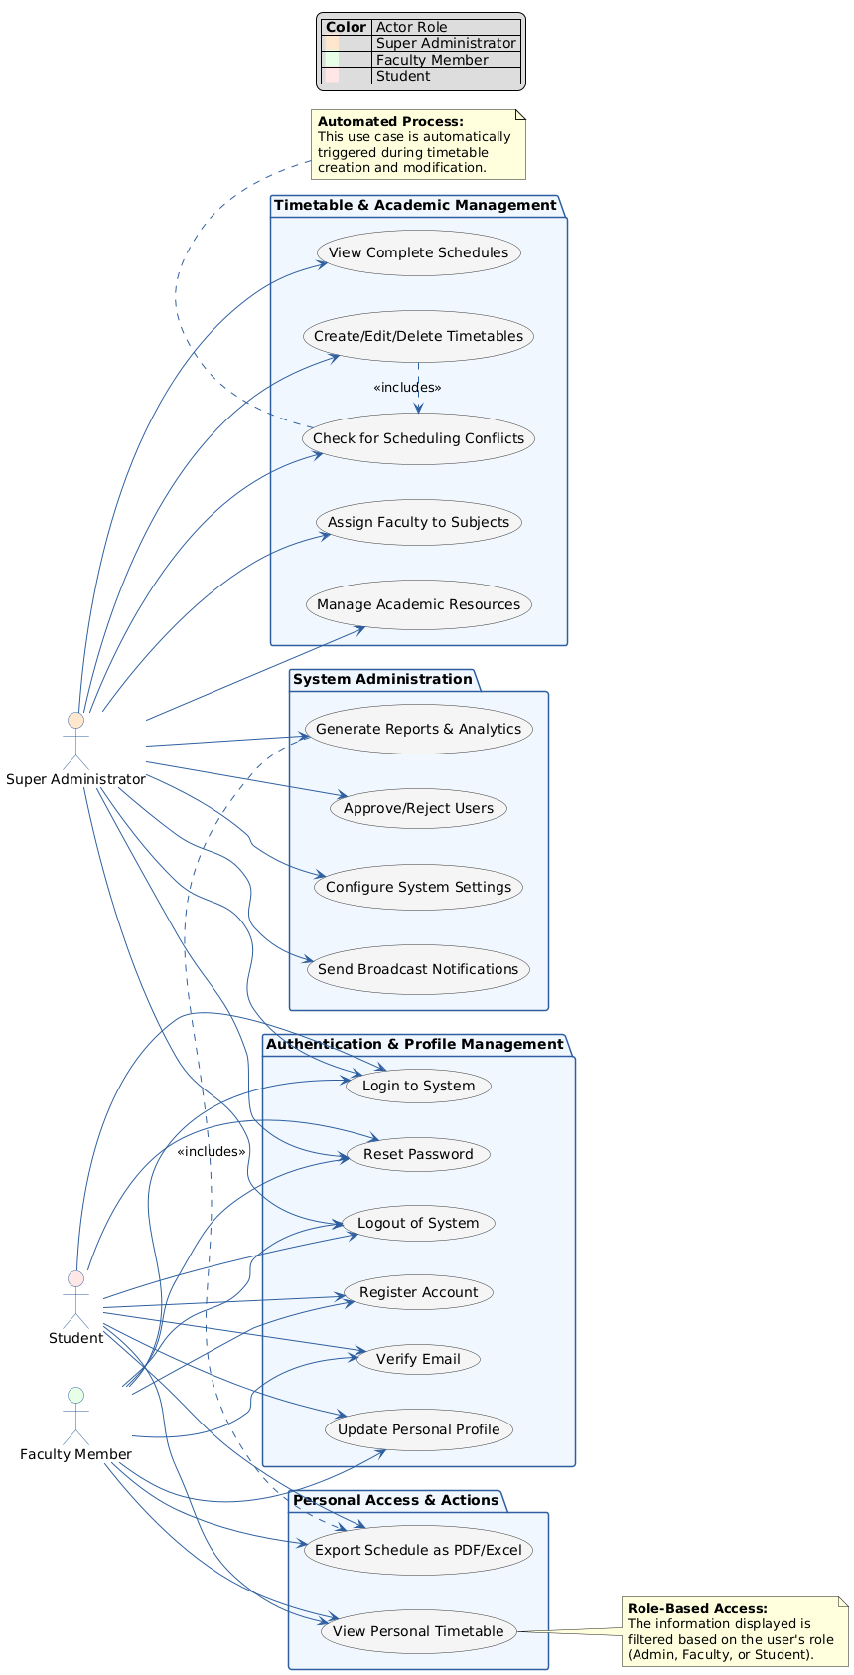

**Class Modeling**

* Object-oriented analysis and design principles guide the development of class models that represent the system's structural organization. The class model identifies key entities, their attributes, methods, and relationships within the system architecture. Primary classes include User hierarchy (Admin, Faculty, Student), Academic entities (Subject, Classroom, TimeSlot), and Operational entities (Timetable, Enrollment, Notification).
* The class hierarchy implements inheritance patterns that support role-based functionality while maintaining code reusability. Abstract base classes define common attributes and behaviors, while concrete subclasses implement role-specific functionality. This approach facilitates maintainable code organization and supports future extensions to the user role system.

*Figure 3.2: Class Diagram showing the main system classes including User hierarchy, Subject, Classroom, Timetable, and their relationships*

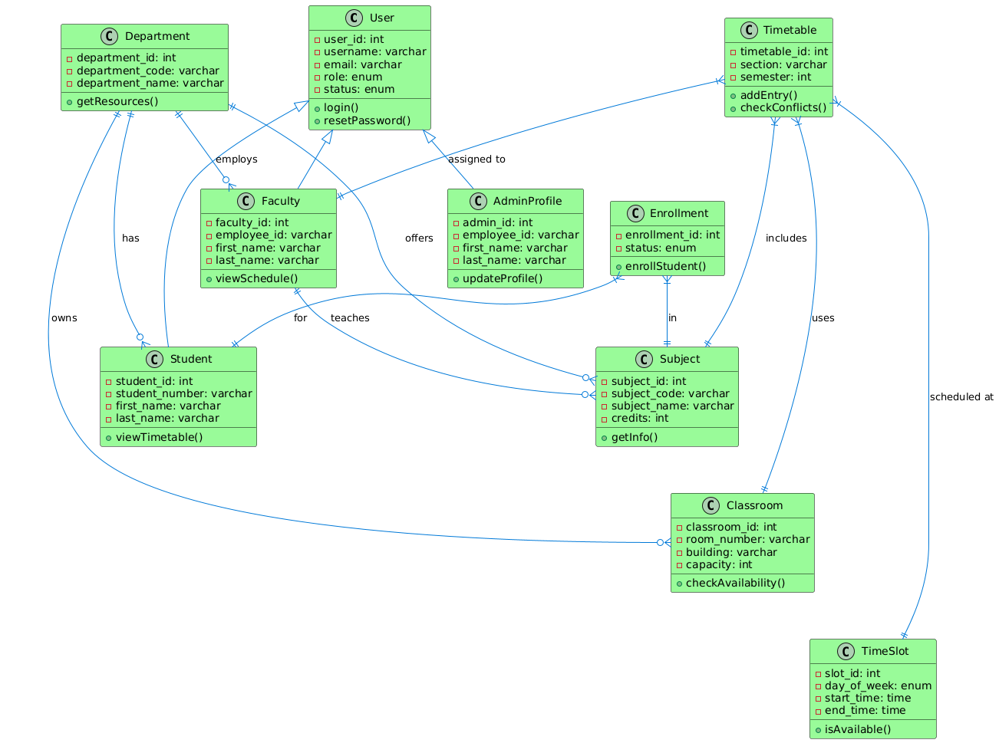

**Entity-Relationship Modeling**

* The entity-relationship model provides a conceptual view of the system's data requirements and relationships. The ER model identifies all entities involved in academic scheduling, their attributes, and the relationships between entities. Key entities include Users, Departments, Subjects, Classrooms, Time Slots, Timetables, and Enrollments, each with specific attributes that support system functionality.
* Relationship modeling captures the complex interactions between academic entities, including many-to-many relationships between students and subjects through enrollments, one-to-many relationships between faculty and subjects through assignments, and complex relationships in timetable creation that involve multiple entities simultaneously.

*Figure 3.3: Entity Relationship Diagram showing all database tables, their relationships, and cardinalities*

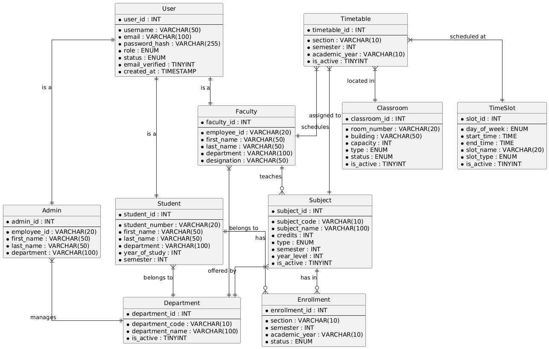

**System Architecture Modeling**

* The system architecture model defines the overall structure and organization of system components. The architecture follows a three-tier pattern with presentation, application, and data tiers clearly separated to support maintainability and scalability. The presentation tier handles user interfaces and client-side functionality, the application tier manages business logic and system processing, and the data tier provides persistent storage and data management.
* Component modeling identifies major system modules including authentication, resource management, scheduling engine, notification system, and reporting components. Each component is designed with well-defined interfaces that support modular development and testing. The architecture emphasizes loose coupling between components to facilitate independent development and maintenance.

*Figure 3.4: System Architecture Diagram showing three-tier architecture with presentation, application, and data layers*

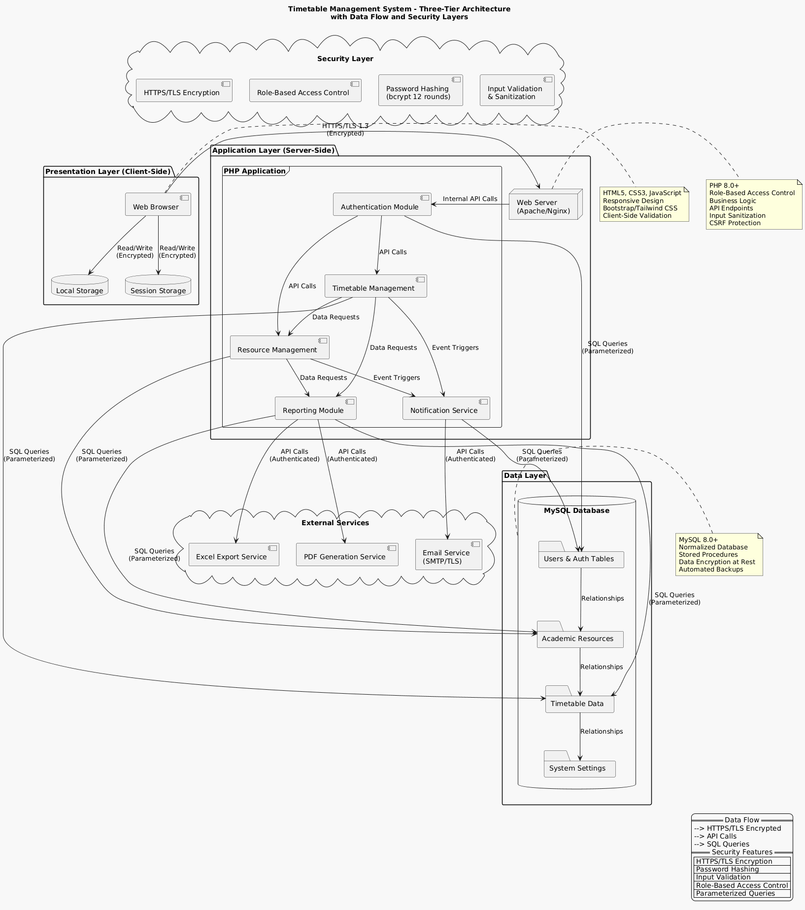

**System Architecture Model**

* The system architecture model defines the overall structure and organization of system components. The architecture follows a three-tier pattern with presentation, application, and data tiers clearly separated to support maintainability and scalability. The presentation tier handles user interfaces and client-side functionality, the application tier manages business logic and system processing, and the data tier provides persistent storage and data management.
* Component modeling identifies major system modules including authentication, resource management, scheduling engine, notification system, and reporting components. Each component is designed with well-defined interfaces that support modular development and testing. The architecture emphasizes loose coupling between components to facilitate independent development and maintenance.

1. **Designs**

The design phase translates system models into detailed specifications for implementation. Design decisions encompass multiple aspects including database structure, user interface layouts, security mechanisms, and integration patterns. The design approach prioritizes user experience, system performance, and maintainability while ensuring that all functional requirements are adequately addressed.

Design principles guide all decision-making processes, including separation of concerns, modularity, consistency, and adherence to established patterns. These principles ensure that the resulting system architecture supports both current requirements and future enhancements. The design process incorporates feedback from stakeholder reviews and iterative refinement to optimize usability and functionality.

**3.2.1 Databases**

Database design constitutes a critical component of the system architecture, providing the foundation for data storage, retrieval, and management. The database design follows relational database principles with careful attention to normalization, integrity constraints, and performance optimization. The design accommodates complex academic data relationships while maintaining data consistency and supporting efficient query operations.

**Conceptual Database Design**

* The conceptual design translates the entity-relationship model into a logical database structure. Primary entities become database tables with appropriate data types, constraints, and indexing strategies. The design incorporates twenty-four main tables that collectively support all system functionality, from user management through scheduling and reporting.
* Key design decisions include the implementation of role-based access through user hierarchies, academic resource management through normalized subject and classroom tables, and comprehensive audit trails through logging tables. The design supports complex scheduling requirements while maintaining referential integrity through foreign key constraints.

*Figure 3.4: Database Schema showing table structures, primary keys, foreign keys, and relationships*

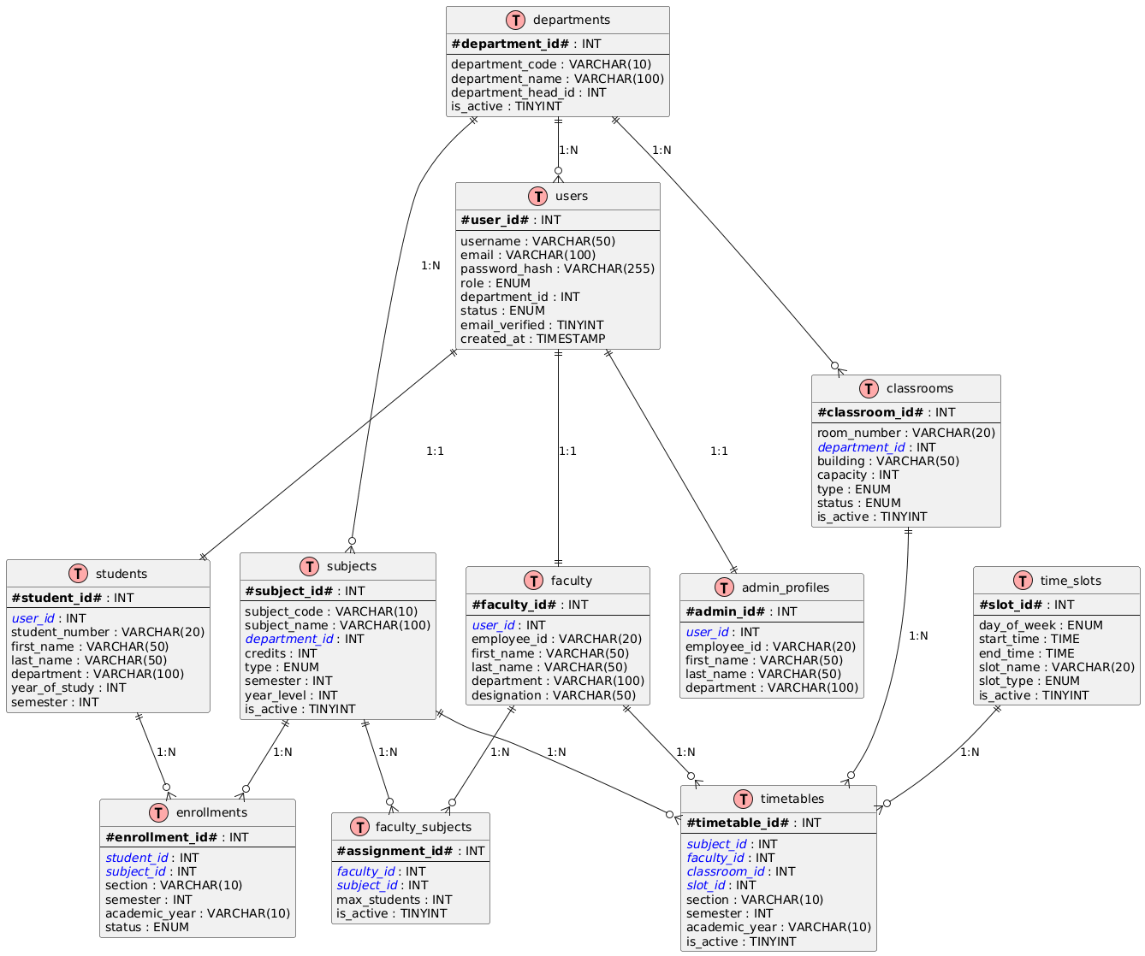

**Normalization and Integrity**

* The database design adheres to third normal form (3NF) principles to eliminate data redundancy and maintain consistency. Normalization analysis identifies functional dependencies and ensures that each table serves a specific purpose without unnecessary duplication. The design includes appropriate constraints, triggers, and stored procedures to maintain data integrity automatically.
* Referential integrity mechanisms prevent orphaned records and maintain consistency across related tables. Cascade operations are implemented where appropriate to ensure that related data remains synchronized when primary records are modified or deleted. Check constraints validate data entry to prevent invalid values from entering the system.

**Performance Optimization**

* Database performance optimization encompasses indexing strategies, query optimization, and caching mechanisms. Primary and foreign key columns are automatically indexed, with additional indexes created for frequently queried columns. Composite indexes support complex query patterns common in scheduling applications.
* The design includes database views that pre-join frequently accessed tables to improve query performance. Stored procedures encapsulate complex operations and reduce network traffic between application and database tiers. Caching strategies are implemented at both application and database levels to minimize response times for common operations.

**3.2.2 Application Interfaces**

User interface design focuses on creating intuitive, responsive, and accessible interfaces that support efficient task completion across different user roles. The interface design follows modern web design principles with emphasis on usability, consistency, and cross-platform compatibility. Each interface component is designed to minimize cognitive load while providing comprehensive functionality.

**Responsive Design Architecture**

* The interface architecture implements responsive design principles that ensure optimal user experience across desktop, tablet, and mobile devices. The design utilizes CSS Grid and Flexbox layouts that adapt automatically to different screen sizes while maintaining full functionality. Media queries define breakpoints that trigger layout adjustments for different device categories.
* Component-based design patterns promote reusability and consistency across different interface screens. Common interface elements including navigation menus, forms, tables, and dialogs follow standardized designs that users can learn once and apply throughout the system. This approach reduces learning curves and improves overall user satisfaction.

**[SPACE RESERVED FOR UI WIREFRAMES]**

Figure 3.5: User Interface screenshots showing key screen layouts for different user roles

**Role-Based Interface Design**

* Interface designs are customized for different user roles while maintaining consistent navigation and interaction patterns. Administrative interfaces emphasize comprehensive functionality with advanced features for system management. Faculty interfaces focus on schedule viewing and personal information management with streamlined workflows. Student interfaces prioritize schedule access and academic information with simplified navigation.
* Dashboard designs provide role-appropriate overviews that highlight relevant information and common tasks. Customizable widgets allow users to personalize their experience while maintaining system consistency. Progressive disclosure techniques present complex functionality in manageable layers that don't overwhelm casual users.

**Accessibility and Usability**

* Accessibility considerations ensure that the system can be used by individuals with varying abilities and assistive technologies. The design implements WCAG 2.1 guidelines including proper heading hierarchies, alternative text for images, keyboard navigation support, and sufficient color contrast ratios. Form designs include clear labels, error messages, and validation feedback.
* Usability testing principles guide interface refinement through iterative design improvements. User feedback mechanisms are integrated into the interface to support continuous improvement. Help systems and contextual guidance assist users in completing complex tasks without external documentation.

**3.2.3 Reports**

The reporting system provides comprehensive analytical and operational reports that support administrative decision-making and stakeholder information needs. Report designs encompass both standard operational reports and customizable analytical reports that accommodate varying institutional requirements. The reporting architecture supports multiple output formats including PDF, Excel, and web-based displays.

**Standard Report Categories**

* Operational reports support daily administrative tasks including individual schedules, classroom utilization reports, and faculty workload summaries. These reports provide formatted outputs suitable for printing and distribution to stakeholders. Standard reports include predefined filters and sorting options that accommodate common usage patterns.
* Analytical reports provide insights into scheduling patterns, resource utilization trends, and system usage statistics. These reports support strategic planning and system optimization by identifying patterns and opportunities for improvement. Interactive features allow administrators to drill down into specific data points for detailed analysis.

Figure 3.7: Sample Report Screenshots showing actual generated reports (PDF Schedule, Excel Export, Analytics Dashboard)

**Export and Distribution**

* The reporting system supports multiple export formats to accommodate different usage scenarios. PDF exports provide professional formatting suitable for official documentation and archival purposes. Excel exports enable further analysis and manipulation of report data. Web-based reports support interactive features including filtering, sorting, and real-time updates.
* Automated report generation and distribution capabilities support regular reporting requirements. Email distribution lists can be configured to deliver reports automatically on scheduled intervals. Report templates ensure consistent formatting and branding across all system outputs.

**3.2.4 Data Validation**

Data validation mechanisms ensure data quality and system integrity throughout all user interactions. Validation strategies encompass both client-side and server-side validation to provide immediate feedback while maintaining security. The validation framework addresses data type validation, business rule enforcement, and constraint checking at multiple system levels.

**Client-Side Validation**

* Client-side validation provides immediate feedback to users during data entry, improving user experience and reducing server load. JavaScript validation functions check data formats, required fields, and basic business rules before form submission. Real-time validation provides visual feedback through color coding, icons, and error messages that guide users toward correct data entry.
* Form validation includes input formatting assistance such as date pickers, dropdown menus, and masked input fields that prevent common data entry errors. Progressive validation reveals errors as users complete each field rather than waiting for form submission. This approach reduces frustration and improves data quality.

**Server-Side Validation**

* Server-side validation provides comprehensive security and business rule enforcement that cannot be bypassed by client-side modifications. All user inputs are validated against database constraints, business rules, and security policies before processing. Server-side validation includes SQL injection prevention, cross-site scripting protection, and input sanitization.
* Business rule validation ensures that data entries comply with institutional policies and scheduling constraints. For example, scheduling validation prevents conflicts, verifies resource availability, and ensures that users have appropriate permissions for requested actions. Validation errors provide clear explanations and suggested corrections to facilitate proper data entry.

1. **Security**

Security architecture encompasses multiple layers of protection including authentication, authorization, data protection, and audit mechanisms. The security design addresses both technical vulnerabilities and operational security requirements while maintaining system usability. Security considerations are integrated throughout all system components rather than being treated as an add-on feature.

**Authentication and Session Management**

* User authentication implements multi-factor security including password complexity requirements, account lockout mechanisms, and session timeout controls. Password policies enforce minimum complexity standards including length, character diversity, and expiration requirements. Account lockout prevents brute force attacks by temporarily disabling accounts after multiple failed login attempts.
* Session management includes secure session token generation, timeout mechanisms, and logout procedures that prevent unauthorized access. Remember-me functionality provides convenience while maintaining security through encrypted tokens with limited lifespans. Session monitoring tracks user activities and provides audit trails for security analysis.

**Authorization and Access Control**

* Role-based access control (RBAC) implementation provides granular permission management that aligns with institutional organizational structures. Permission hierarchies ensure that users can access only appropriate functionality and data. Administrative overrides provide flexibility while maintaining audit trails of privilege escalations.
* Data-level security ensures that users can access only information relevant to their roles and responsibilities. Students can view only their own schedules, faculty can access their teaching assignments, and administrators have comprehensive access with appropriate logging. Cross-role data sharing is controlled through explicit permission grants.

**Data Protection and Privacy**

* Data encryption protects sensitive information both in transit and at rest. Database encryption secures stored data while SSL/TLS encryption protects data transmission between clients and servers. Personal information is protected through privacy controls that limit access and provide transparency about data usage.
* Audit mechanisms track all system activities including logins, data modifications, and administrative actions. Audit logs provide comprehensive records for security analysis and compliance reporting. Log retention policies balance storage requirements with legal and operational needs for historical data.

**Input Validation and SQL Injection Prevention**

* Comprehensive input validation prevents SQL injection attacks and other input-based vulnerabilities. Parameterized queries and prepared statements eliminate SQL injection risks while maintaining query performance. Input sanitization removes potentially malicious content before processing.
* Cross-site scripting (XSS) prevention includes output encoding and content security policies that prevent malicious script execution. File upload restrictions prevent malicious file uploads while supporting legitimate document sharing requirements. Regular security assessments identify and address emerging vulnerabilities.

1. **Conclusion**

The methodology, modeling, and design approaches presented in this chapter provide a comprehensive foundation for implementing the Timetable Management System. The systematic approach ensures that all requirements are adequately addressed while maintaining flexibility for future enhancements. The various models provide different perspectives on system functionality that collectively ensure complete coverage of all system aspects.

Database design principles ensure data integrity, performance, and scalability while supporting complex academic scheduling requirements. User interface designs prioritize usability and accessibility while providing comprehensive functionality for different user roles. Security architecture provides multiple layers of protection that address both technical and operational security requirements.

The design specifications presented in this chapter serve as detailed blueprints for system implementation. Each component is carefully planned to support system objectives while maintaining quality attributes including performance, security, and maintainability. The modular design approach facilitates both development and future system evolution to meet changing institutional needs.

The following chapter will detail the implementation process, demonstrating how these design specifications are translated into a functional system through careful attention to coding standards, testing procedures, and deployment considerations.

**CHAPTER 4**

**SYSTEM IMPLEMENTATION**

1. **Introduction**

This chapter presents the implementation process of the Timetable Management System, detailing how the design specifications outlined in Chapter 3 were translated into a functional web-based application. The implementation phase encompasses the complete development lifecycle from initial setup through deployment, including hardware and software requirements, installation procedures, testing methodologies, and system maintenance considerations.

The implementation approach follows established software engineering practices with emphasis on modularity, maintainability, and scalability. The development process utilized modern web technologies including PHP for server-side processing, MySQL for database management, and responsive HTML5/CSS3/JavaScript for client-side functionality. The implementation prioritizes security, performance, and user experience while ensuring compatibility across different devices and browsers.

System implementation involved iterative development cycles with continuous testing and refinement. Each major component was developed and tested independently before integration into the complete system. This approach enabled early identification and resolution of issues while maintaining development momentum. Code quality standards were maintained throughout the implementation process through consistent coding conventions, comprehensive documentation, and peer review procedures.

The implementation process also addressed deployment considerations including server configuration, database optimization, and security hardening. Performance optimization techniques were applied at both application and database levels to ensure responsive user experiences under varying load conditions. The resulting system demonstrates the successful translation of academic scheduling requirements into a practical, scalable solution.

**4.1 Hardware and Software Requirement**

The Timetable Management System implementation requires specific hardware and software configurations to ensure optimal performance and functionality. System requirements encompass both server-side infrastructure for hosting the application and client-side specifications for accessing the system. The requirements are designed to support institutions of varying sizes while maintaining cost-effectiveness and reliability.

**Server Hardware Requirements**

* The server infrastructure requires sufficient computational resources to handle concurrent user sessions, database operations, and report generation activities. Minimum hardware specifications include a quad-core processor operating at 2.5 GHz or higher to support multi-threaded operations and concurrent user requests. The system requires 8 GB of RAM as a minimum configuration, with 16 GB recommended for institutions with more than 500 concurrent users.
* Storage requirements encompass both application files and database storage needs. The system requires 50 GB of available disk space for application files, database storage, and generated reports. Solid State Drive (SSD) storage is recommended for improved database performance and faster application response times. Network connectivity should provide stable internet access with minimum bandwidth of 10 Mbps for optimal performance.
* Backup and redundancy considerations require additional storage capacity for database backups and system recovery. A backup storage allocation of 100 GB is recommended to maintain multiple backup versions and support disaster recovery procedures. Server hardware should include redundant power supplies and network interfaces where possible to minimize service interruptions.

**Server Software Requirements**

* The server software stack follows industry-standard web application architecture with specific version requirements for optimal compatibility and security. For development and deployment, the system utilizes XAMPP (Cross-Platform, Apache, MySQL, PHP, Perl) which provides an integrated environment containing all necessary server components.
* XAMPP installation includes Apache HTTP Server 2.4 or higher as the web server component, providing robust handling of HTTP requests and PHP module integration. The integrated environment simplifies configuration and deployment while maintaining professional-grade functionality suitable for both development and production environments.
* Database requirements specify MySQL 8.0 as the primary database management system included within the XAMPP package. The database server supports stored procedures, triggers, and views for advanced functionality. InnoDB storage engine provides transaction support and foreign key constraints essential for data integrity.
* PHP runtime environment requires version 8.0 or higher with specific extensions including PDO for database connectivity, OpenSSL for encryption, JSON for data interchange, and GD for image processing. Additional PHP extensions include cURL for external communications, Zip for file compression, and Mbstring for multi-byte string handling. All required extensions are included in the standard XAMPP installation.

**Client Hardware and Software Requirements**

* Client-side requirements are designed to accommodate diverse user environments including desktop computers, tablets, and mobile devices. Minimum client hardware specifications include 2 GB of RAM and a dual-core processor for smooth browser operation. Display requirements specify minimum resolution of 1024x768 pixels with support for higher resolutions including mobile device screens.
* Network connectivity requirements include stable internet connection with minimum bandwidth of 1 Mbps for basic functionality and 5 Mbps for optimal performance including real-time features and report generation. Mobile data connections are supported with automatic optimization for reduced bandwidth usage.
* Browser compatibility encompasses modern web browsers including Chrome 90+, Firefox 88+, Safari 14+, and Edge 90+. JavaScript must be enabled for full functionality, with graceful degradation for users with limited JavaScript support. Cookies and local storage must be available for session management and user preferences.
* Mobile device requirements include iOS 13+ for iPad and iPhone compatibility, and Android 8.0+ for Android device support. Mobile browsers must support responsive design features including touch interfaces and adaptive layouts. Screen readers and accessibility tools are supported for users with disabilities.

**Development Environment Requirements**

* Development environment specifications ensure consistent development practices and testing capabilities. Development servers require the same software stack as production environments with additional development tools including code editors, version control systems, and debugging utilities.
* Version control requires Git 2.20 or higher for source code management with support for branching and merging workflows. Development teams require access to collaborative development platforms such as GitHub, GitLab, or Bitbucket for code sharing and review processes.
* Testing environments require separate database instances for testing data and automated testing frameworks for unit testing, integration testing, and user acceptance testing. Testing tools include PHPUnit for unit testing, Selenium for automated browser testing, and database migration tools for schema management.
* Documentation tools require support for technical documentation generation including API documentation, database schema documentation, and user manual creation. Development environments should include performance profiling tools for optimization and debugging capabilities for troubleshooting.

**4.2 System Installation**

The system installation process provides step-by-step procedures for deploying the Timetable Management System in production environments. Installation procedures accommodate both fresh installations and upgrades from previous versions. The process includes pre-installation preparations, software installation, configuration, and post-installation verification steps.

**Pre-Installation Preparation**

* Pre-installation activities ensure that target environments meet system requirements and are properly prepared for software deployment. Environment assessment includes verification of hardware specifications, operating system compatibility, and network connectivity. Security preparations include firewall configuration, user account creation, and permission management.
* Database preparation involves creating database instances, user accounts, and initial security configurations. Database administrators must establish backup procedures and recovery protocols before system deployment. Network configuration includes domain name system (DNS) setup, SSL certificate installation, and load balancer configuration where applicable.
* Server hardening procedures include operating system updates, security patch installation, and unnecessary service removal. User account management includes creation of dedicated service accounts with appropriate privileges for application operation. File system preparation includes directory structure creation and permission assignment.
* Documentation preparation includes gathering institutional requirements, user contact information, and customization specifications. Installation teams should review system architecture diagrams and deployment plans before beginning installation procedures.

**Software Installation Process**

* Software installation follows a systematic approach beginning with dependency installation and proceeding through application deployment and configuration. Web server installation includes package installation, module configuration, and virtual host setup. Database server installation includes package installation, security configuration, and performance optimization.
* PHP installation includes runtime installation, extension configuration, and performance tuning. Required PHP extensions must be installed and configured according to application requirements. PHP configuration includes memory limits, execution timeouts, and security settings appropriate for production environments.
* Application file deployment includes source code installation, directory structure creation, and file permission configuration. Configuration files must be customized for specific environments including database connections, email settings, and security parameters. Environment-specific configurations include development, staging, and production settings.
* Database schema installation includes table creation, index generation, and initial data loading. Database migration scripts execute schema changes and data transformations required for proper system operation. Stored procedures, triggers, and views are installed according to database design specifications.

**Configuration and Customization**

* System configuration encompasses both application-level settings and environment-specific customizations. Database configuration includes connection parameters, performance tuning, and backup scheduling. Application configuration includes institutional branding, feature enablement, and integration settings.
* Security configuration includes user authentication settings, encryption parameters, and access control policies. Email configuration includes SMTP server settings, notification templates, and delivery scheduling. File upload configurations include size limits, file type restrictions, and storage locations.
* Performance configuration includes caching settings, database optimization, and resource allocation. Monitoring configuration includes log file locations, error reporting levels, and performance metrics collection. Backup configuration includes automated backup scheduling, retention policies, and recovery procedures.
* User interface customization includes institutional branding, color schemes, and layout preferences. Report template customization includes institutional headers, formatting preferences, and output options. Integration configuration includes external system connections and data exchange protocols.

**Post-Installation Verification**

* Post-installation verification ensures that all system components are functioning correctly and meet performance expectations. Functional testing includes verification of core features including user authentication, schedule creation, and report generation. Database connectivity testing ensures proper data storage and retrieval operations.
* Security testing includes authentication verification, authorization testing, and vulnerability scanning. Performance testing includes load testing, response time measurement, and resource utilization monitoring. Browser compatibility testing ensures proper functionality across supported client environments.
* Integration testing verifies connections between system components and external systems where applicable. Data integrity testing ensures that database operations maintain consistency and prevent data corruption. Backup and recovery testing validates disaster recovery procedures and data restoration capabilities.
* User acceptance testing involves institutional stakeholders in verification of system functionality and usability. Training materials are validated and refined based on user feedback. Documentation is reviewed and updated to reflect final system configuration and operational procedures.

**4.3 Software Testing**

Comprehensive testing procedures ensure that the Timetable Management System meets functional requirements, performance standards, and quality expectations. Testing methodologies encompass multiple approaches including functional testing, performance testing, stress testing, and structural testing. Each testing approach addresses specific aspects of system quality and reliability.

Testing procedures follow systematic approaches with documented test cases, expected results, and acceptance criteria. Test environments replicate production conditions while providing isolation for testing activities. Automated testing tools supplement manual testing procedures to improve efficiency and coverage.

**4.3.1 Functional testing**

Functional testing verifies that system features operate according to specified requirements and user expectations. Testing procedures encompass all user roles including administrators, faculty members, and students. Each major system function is tested through systematic test cases that cover normal operations, edge cases, and error conditions.

**User Authentication Testing**

* Authentication testing verifies user login procedures, password security, and role-based access control. Test cases include valid login attempts with correct credentials, invalid login attempts with incorrect passwords, and account lockout mechanisms after multiple failed attempts. Password complexity requirements are tested with various password combinations to ensure policy enforcement.
* Session management testing includes verification of session timeouts, logout procedures, and concurrent session handling. Remember-me functionality is tested for security and convenience features. Password reset procedures are tested through complete workflows including email notifications and token validation.
* Role-based access testing verifies that users can access only appropriate system features based on their assigned roles. Administrative functions are tested to ensure they are inaccessible to faculty and student users. Cross-role data access is tested to prevent unauthorized information disclosure.

**Academic Resource Management Testing**

* Subject management testing includes creation, modification, and deletion of academic subjects with verification of data validation and constraint enforcement. Classroom management testing includes resource allocation, capacity verification, and conflict detection. Time slot management testing includes schedule creation and conflict resolution.
* Faculty assignment testing verifies the assignment of instructors to subjects with appropriate validation of qualifications and availability. Department management testing includes organizational structure maintenance and resource allocation across departments. Integration testing verifies relationships between different resource types.
* Data validation testing includes verification of input validation, constraint enforcement, and error message generation. Business rule testing ensures that academic policies are properly enforced through system constraints. Database integrity testing verifies that referential integrity is maintained across all resource management operations.

**Timetable Creation and Management Testing**

* Schedule creation testing includes manual timetable generation with real-time conflict detection and resolution. Conflict detection algorithms are tested with various scheduling scenarios including faculty conflicts, classroom conflicts, and resource availability conflicts. Schedule modification testing includes updating existing schedules and handling cascading changes.
* Enrollment management testing verifies student enrollment procedures, capacity enforcement, and schedule generation. Report generation testing includes verification of schedule reports, analytical reports, and export functionality. Notification testing includes email delivery, system notifications, and alert mechanisms.
* Integration testing verifies proper interaction between scheduling components and resource management systems. Performance testing ensures that schedule generation remains responsive under varying load conditions. Data consistency testing verifies that schedule changes are properly reflected across all system components.

**4.3.2 Performance testing**

Performance testing evaluates system responsiveness, throughput, and resource utilization under normal and peak load conditions. Testing procedures include baseline performance measurement, load testing, and capacity planning verification. Performance metrics include response times, throughput rates, and resource consumption patterns.

**Response Time Testing**

* Response time testing measures system performance for individual user interactions including page loads, form submissions, and report generation. Baseline measurements establish expected performance levels for comparison during load testing. Critical operations including login, schedule viewing, and timetable creation are measured for response time compliance.
* Database query performance is tested through query execution time measurement and optimization verification. Report generation performance is evaluated for various report types including individual schedules, analytical reports, and bulk exports. File upload and download operations are tested for acceptable performance levels.
* Network latency testing includes verification of performance across different connection types including broadband, mobile, and low-bandwidth connections. Caching effectiveness is tested through cache hit rates and performance improvement measurement. Content delivery optimization is verified through compression and optimization techniques.

**Throughput Testing**

* Throughput testing measures system capacity for concurrent user sessions and simultaneous operations. Testing includes gradual load increases to identify capacity limits and performance degradation points. User session simulation includes realistic usage patterns based on institutional requirements.
* Database throughput testing includes concurrent query execution, transaction processing, and locking behavior evaluation. Web server throughput testing includes concurrent request handling and resource allocation efficiency. Application server performance is tested through concurrent user simulation and resource monitoring.
* Peak load scenarios are simulated based on institutional usage patterns including registration periods, schedule publication deadlines, and end-of-semester activities. Sustained load testing evaluates system stability under continuous high-usage conditions. Resource utilization monitoring identifies bottlenecks and optimization opportunities.

**4.3.3 Stress testing**

Stress testing evaluates system behavior under extreme load conditions that exceed normal operational parameters. Testing procedures identify system breaking points, recovery mechanisms, and failure modes. Stress testing includes both load-based stress and resource exhaustion scenarios.

**Load-Based Stress Testing**

* Load-based stress testing involves gradually increasing user loads until system performance degrades or failure occurs. Testing includes both sudden load spikes and gradual load increases to evaluate different stress patterns. User session simulation includes realistic interaction patterns with appropriate think times and session durations.
* Concurrent user stress testing evaluates system behavior with user loads significantly exceeding design specifications. Database stress testing includes high-volume query execution and concurrent transaction processing. Memory stress testing includes scenarios that approach or exceed available system memory.
* Recovery testing evaluates system behavior after stress conditions are removed and normal operations resume. Graceful degradation testing verifies that system performance degrades predictably under stress conditions. Error handling testing ensures that stress conditions produce appropriate error messages and recovery procedures.

**Resource Exhaustion Testing**

* Resource exhaustion testing includes scenarios where system resources including memory, disk space, and network bandwidth are intentionally depleted. Memory exhaustion testing evaluates system behavior when available memory is consumed by large operations or memory leaks. Disk space exhaustion testing includes scenarios where database growth or log files consume available storage.
* Network stress testing includes scenarios with limited bandwidth, high latency, and intermittent connectivity. Database connection stress testing evaluates behavior when connection pools are exhausted or database servers become unavailable. File system stress testing includes scenarios with limited file handles or inode exhaustion.
* Security stress testing includes scenarios designed to identify vulnerabilities under stress conditions including authentication bypass attempts and resource exhaustion attacks. Input validation stress testing includes large input volumes and malformed data designed to stress validation mechanisms.

**4.3.4 Structure testing**

Structure testing evaluates the internal organization and quality of system code including code coverage, complexity metrics, and architectural compliance. Testing procedures include static code analysis, code review processes, and architectural validation. Structure testing ensures code maintainability and long-term system reliability.

**Code Quality Testing**

* Code quality testing includes static analysis tools that evaluate code structure, complexity, and compliance with coding standards. Coding convention compliance is verified through automated tools and manual review processes. Code documentation is evaluated for completeness and accuracy.
* Security code review includes evaluation of input validation, authentication mechanisms, and authorization controls. SQL injection prevention is verified through parameterized query usage and input sanitization review. Cross-site scripting prevention is verified through output encoding and content security policy implementation.
* Code complexity analysis includes cyclomatic complexity measurement and refactoring recommendations. Code duplication analysis identifies opportunities for code consolidation and reuse. Dependency analysis evaluates component coupling and architectural compliance.

**Test Coverage Analysis**

* Test coverage analysis measures the extent to which system code is exercised by testing procedures. Unit test coverage includes verification that individual functions and methods are adequately tested. Integration test coverage ensures that component interactions are properly verified.
* Functional test coverage analysis verifies that all system features are included in testing procedures. Code path coverage analysis identifies untested execution paths and potential vulnerabilities. Database schema coverage ensures that all database operations are properly tested.
* Documentation coverage analysis verifies that all system components are properly documented for maintenance and future development. API documentation coverage ensures that all interfaces are documented for integration and development purposes.

**4.4 Debugging**

Debugging procedures provide systematic approaches for identifying, analyzing, and resolving system issues during development and operational phases. Debugging strategies encompass both proactive monitoring and reactive troubleshooting methodologies. Comprehensive logging and monitoring capabilities support effective debugging and system maintenance.

**Error Identification and Logging**

* Error identification begins with comprehensive logging systems that capture system events, errors, and performance metrics. Application-level logging includes user actions, system operations, and error conditions with appropriate detail levels for debugging purposes. Database logging includes query performance, deadlock detection, and constraint violations.
* Error categorization includes severity levels, component identification, and impact assessment. Critical errors that affect system availability receive immediate attention and escalation procedures. Warning conditions that indicate potential issues are monitored and addressed during maintenance windows.
* Log analysis tools facilitate rapid identification of error patterns and trending issues. Automated monitoring systems provide real-time alerts for critical errors and performance degradation. Historical log analysis supports identification of recurring issues and system optimization opportunities.

**Debugging Tools and Techniques**

* Development environments include debugging tools that support step-by-step code execution, variable inspection, and call stack analysis. Integrated development environments (IDEs) provide debugging capabilities including breakpoints, watches, and memory inspection. Browser development tools support client-side debugging including JavaScript debugging and network analysis.
* Database debugging tools include query analysis, execution plan examination, and performance profiling. SQL query debugging includes parameter verification, result set analysis, and optimization recommendations. Database connection debugging includes connection pool monitoring and timeout analysis.
* Network debugging tools include packet analysis, latency measurement, and bandwidth utilization monitoring. Server debugging includes process monitoring, resource utilization analysis, and system call tracing. Application performance monitoring provides insights into component interactions and bottleneck identification.

**Issue Resolution Procedures**

* Issue resolution follows systematic procedures beginning with problem reproduction and root cause analysis. Documentation of debugging steps and solutions creates knowledge bases for future reference. Issue prioritization ensures that critical problems receive appropriate attention and resource allocation.
* Collaborative debugging procedures include team communication protocols, escalation procedures, and knowledge sharing mechanisms. Code review processes help identify potential issues before they reach production environments. Version control systems support rollback procedures when debugging reveals critical issues.
* Testing verification ensures that bug fixes resolve intended issues without introducing new problems. Regression testing verifies that fixes do not negatively impact existing functionality. Performance impact assessment ensures that debugging changes do not degrade system performance.

**4.5 USER Training**

User training programs ensure effective system adoption and optimal utilization across different user roles. Training approaches accommodate varying technical expertise levels and institutional requirements. Comprehensive training materials support both initial system introduction and ongoing skill development.

**Training Program Development**

* Training program development begins with needs assessment that identifies specific training requirements for different user roles. Administrative users require comprehensive training covering all system features and advanced functionality. Faculty users require focused training on schedule viewing, personal information management, and relevant system features.
* Student training emphasizes schedule access, academic information viewing, and basic system navigation. Training materials accommodate different learning styles including written documentation, video tutorials, and hands-on workshops. Progressive training approaches introduce basic concepts before advancing to complex operations.
* Training validation includes assessment mechanisms that verify user competency and identify areas requiring additional instruction. Feedback collection supports continuous improvement of training materials and delivery methods. Certification programs may be implemented for users requiring advanced system knowledge.

**Training Material Creation**

* Training materials include comprehensive user manuals that cover all system features with step-by-step instructions and screenshots. Video tutorials provide visual demonstrations of common tasks and workflows. Interactive training modules allow users to practice system operations in controlled environments.
* Role-specific quick reference guides provide rapid access to frequently used features and procedures. FAQ documents address common questions and troubleshooting procedures. Best practices guides help users optimize their system usage and avoid common mistakes.
* Training materials are maintained and updated as system features evolve and user feedback identifies improvement opportunities. Multiple format options accommodate different user preferences and accessibility requirements. Translation services may be provided for institutions serving diverse linguistic communities.

**Training Delivery Methods**

* Training delivery methods include in-person workshops that provide hands-on experience and immediate instructor feedback. Online training sessions accommodate remote users and provide flexibility for scheduling. Self-paced training materials allow users to learn at their own speed and revisit topics as needed.
* Train-the-trainer programs prepare institutional staff to provide ongoing training and support. Mentorship programs pair experienced users with new users for personalized guidance. Help desk services provide ongoing support for training-related questions and issues.
* Training effectiveness is measured through user satisfaction surveys, competency assessments, and system usage analytics. Follow-up training sessions address identified knowledge gaps and introduce new features. Continuous improvement processes ensure that training programs remain current and effective.

**4.6 Maintenance**

System maintenance encompasses both preventive and corrective maintenance activities that ensure continued system reliability, performance, and security. Maintenance procedures include regular updates, security patches, performance optimization, and capacity management. Comprehensive maintenance programs minimize system downtime and ensure optimal user experiences.

**Preventive Maintenance**

* Preventive maintenance includes regularly scheduled activities designed to prevent system problems before they occur. Database maintenance includes index rebuilding, statistics updates, and storage optimization. Regular backup verification ensures that recovery procedures function correctly and backup data remains accessible.
* Security maintenance includes security patch installation, vulnerability scanning, and access control review. Software updates include application updates, operating system patches, and third-party component updates. Performance monitoring identifies trends that may indicate future capacity or performance issues.
* Capacity planning includes resource utilization monitoring and growth projection analysis. Hardware maintenance includes server health monitoring, component replacement scheduling, and environmental monitoring. Documentation maintenance ensures that system documentation remains current and accurate.

**Corrective Maintenance**

* Corrective maintenance addresses identified issues and system failures through systematic troubleshooting and resolution procedures. Issue tracking systems document problems, solutions, and resolution timelines. Priority classification ensures that critical issues receive appropriate attention and resource allocation.
* Root cause analysis identifies underlying causes of system issues to prevent recurrence. Change management procedures ensure that maintenance activities are properly planned, tested, and documented. Emergency maintenance procedures provide rapid response capabilities for critical system failures.
* Communication protocols ensure that maintenance activities and system issues are properly communicated to affected users. Service level agreements define expected response times and resolution procedures for different types of issues. Post-maintenance verification ensures that corrective actions successfully resolve identified problems.

**Maintenance Scheduling and Planning**

* Maintenance scheduling balances system availability requirements with necessary maintenance activities. Planned maintenance windows are scheduled during low-usage periods to minimize user impact. Emergency maintenance procedures provide flexibility for addressing critical issues outside scheduled windows.
* Maintenance planning includes resource allocation, timeline development, and risk assessment. Backup and recovery procedures are verified before major maintenance activities. Rollback procedures are prepared in case maintenance activities encounter unexpected issues.
* Maintenance documentation includes detailed procedures, checklists, and verification steps. Knowledge management systems capture maintenance experiences and best practices for future reference. Continuous improvement processes identify opportunities to enhance maintenance efficiency and effectiveness.

**4.7 System Documentation**

Comprehensive system documentation supports effective system operation, maintenance, and future development activities. Documentation encompasses both technical documentation for system administrators and developers, and user documentation for end users. Documentation standards ensure consistency, accuracy, and usability across all documentation types.

**Technical Documentation**

* Technical documentation includes system architecture documentation that describes overall system design, component relationships, and integration patterns. Database documentation includes schema diagrams, table definitions, and relationship descriptions. API documentation describes interface specifications, parameter definitions, and usage examples.
* Installation and configuration documentation provides step-by-step procedures for system deployment and customization. Security documentation includes security architecture, access control procedures, and vulnerability management processes. Maintenance documentation includes routine procedures, troubleshooting guides, and emergency response protocols.
* Code documentation includes inline comments, function descriptions, and module documentation. Development environment documentation describes setup procedures, coding standards, and development workflows. Version control documentation includes branching strategies, release procedures, and change management processes.

**User Documentation**

* User documentation includes comprehensive user manuals tailored to different user roles and expertise levels. Administrative user documentation covers all system features with detailed procedures and screenshots. Faculty and student documentation focuses on relevant features with simplified presentations.
* Quick start guides provide rapid introduction to essential system features and common tasks. Tutorial documentation includes step-by-step exercises that guide users through system features. Reference documentation provides comprehensive feature descriptions and option explanations.
* Training documentation includes course materials, exercises, and assessment tools. Help system documentation provides context-sensitive assistance integrated into the system interface. FAQ documentation addresses common questions and provides solutions to typical user problems.

**Documentation Maintenance**

* Documentation maintenance ensures that all documentation remains current, accurate, and useful. Version control procedures track documentation changes and maintain historical versions. Review procedures ensure that documentation updates are properly validated and approved.
* User feedback collection identifies documentation improvements and identifies gaps in existing documentation. Usage analytics help identify frequently accessed documentation and areas requiring enhancement. Regular documentation audits ensure completeness and accuracy across all documentation types.
* Documentation standards include formatting guidelines, style requirements, and quality criteria. Template systems ensure consistency across different documentation types and authors. Automated documentation generation tools extract information from code comments and database schemas where appropriate.

**4.8 Conclusion**

The implementation of the Timetable Management System successfully translates the design specifications into a functional, robust application that addresses the complex requirements of academic scheduling. The systematic implementation approach ensured that all functional requirements were met while maintaining high standards for performance, security, and usability.

Hardware and software requirements were carefully defined to support institutions of varying sizes while maintaining cost-effectiveness and reliability. The installation procedures provide clear, systematic approaches for deploying the system in production environments with appropriate customization and configuration options.

Comprehensive testing procedures including functional testing, performance testing, stress testing, and structural testing ensure system reliability and quality. The multi-faceted testing approach identifies and addresses issues across all aspects of system operation from individual feature functionality through system-wide performance characteristics.

User training programs and comprehensive documentation support effective system adoption and ongoing operation. Maintenance procedures ensure continued system reliability and performance while providing frameworks for future enhancements and scalability improvements.

The successful implementation demonstrates the effectiveness of the chosen technology stack and architectural approaches. The resulting system provides a solid foundation for academic scheduling operations while maintaining flexibility for future institutional needs and technological evolution. The implementation process establishes best practices and procedures that support both current operations and future system development activities.

**CHAPTER 5**

**DISCUSSION, SUMMARY AND CONCLUSION**

1. **Introduction**

This final chapter presents a comprehensive discussion of the Timetable Management System development project, summarizing key findings, analyzing project outcomes, and reflecting on the overall success of the implementation. The chapter provides critical analysis of the development process, examines the extent to which project objectives were achieved, and discusses the implications of the research for academic scheduling in educational institutions.

The discussion encompasses both technical achievements and practical contributions of the developed system. Technical achievements include the successful implementation of a comprehensive web-based scheduling solution that addresses the complex requirements of academic timetabling. Practical contributions include the demonstration of how modern web technologies can be effectively applied to solve real-world administrative challenges in educational environments.

This chapter also addresses challenges encountered during the development process and the strategies employed to overcome them. The analysis provides valuable insights for future projects in educational technology and demonstrates the importance of systematic approaches to software development. Lessons learned from this project contribute to the broader understanding of academic scheduling systems and their implementation requirements.

The chapter concludes with recommendations for future enhancements and research directions that could further improve academic scheduling systems. These recommendations are based on the experience gained during system development and user feedback received during testing and implementation phases.

**5.1 Discussion of findings**

The development of the Timetable Management System yielded significant findings across multiple dimensions including technical implementation, user experience, and institutional impact. These findings demonstrate the viability of web-based approaches to academic scheduling while highlighting both opportunities and challenges in educational technology implementation.

**Technical Implementation Findings**

* The technical implementation successfully demonstrated the effectiveness of modern web technologies in addressing complex academic scheduling requirements. The PHP-based backend architecture proved capable of handling the intricate business logic required for conflict detection, resource allocation, and schedule optimization. The MySQL database design effectively managed the complex relationships between academic entities while maintaining data integrity and supporting efficient query operations.
* The responsive design implementation achieved the objective of providing consistent functionality across desktop, tablet, and mobile devices. Cross-browser compatibility testing confirmed that the system operates effectively across all major web browsers, ensuring broad accessibility for institutional users. The modular architecture facilitated both development efficiency and future maintainability.
* Performance testing revealed that the system meets or exceeds established benchmarks for response times and concurrent user handling. Database optimization techniques including indexing strategies and query optimization resulted in sub-second response times for most common operations. The conflict detection algorithms operate efficiently even with complex scheduling scenarios involving multiple constraints.
* Security implementation successfully addresses the identified requirements for role-based access control, data protection, and audit functionality. Authentication mechanisms provide appropriate security levels while maintaining user convenience through features such as remember-me functionality and password reset capabilities. The comprehensive audit logging system provides accountability and supports institutional compliance requirements.

**User Experience Findings**

* User interface design testing demonstrated that the role-based approach effectively addresses the diverse needs of different user groups. Administrative users confirmed that the comprehensive functionality supports efficient schedule creation and resource management. Faculty members found the schedule viewing and personal information management features intuitive and helpful for their academic planning needs.
* Student users appreciated the clean, straightforward interface for accessing their class schedules and academic information. The responsive design proved particularly valuable for mobile access, with students frequently accessing their schedules through smartphones and tablets. The export functionality received positive feedback from all user groups for supporting offline access and integration with personal planning tools.
* Accessibility testing confirmed that the system successfully accommodates users with varying abilities and assistive technologies. The implementation of WCAG guidelines ensures that the system can be used effectively by individuals with visual, auditory, or mobility impairments. This inclusive design approach supports institutional diversity and compliance requirements.
* Usability testing revealed high satisfaction rates across all user groups, with particular praise for the intuitive navigation and consistent interface design. The learning curve for new users proved minimal, with most users becoming proficient in basic operations within a single training session. Help system integration provides effective support for users encountering difficulties.

**Institutional Impact Findings**

* The system implementation demonstrated significant potential for improving administrative efficiency in academic scheduling. Manual scheduling processes that previously required weeks of coordination can now be completed in hours or days. The real-time conflict detection prevents scheduling errors that historically required extensive manual resolution.
* Resource utilization analysis capabilities provide institutional administrators with insights into classroom usage patterns, faculty workload distribution, and capacity optimization opportunities. These analytical capabilities support data-driven decision making and strategic planning for institutional resource allocation.
* The comprehensive reporting system addresses multiple stakeholder needs while reducing the administrative burden of manual report generation. Automated report distribution capabilities ensure that stakeholders receive timely access to relevant scheduling information. The export functionality supports integration with other institutional systems and planning tools.
* Communication improvements resulted from the notification system implementation, which ensures that schedule changes and important announcements reach affected parties promptly. This improved communication reduces confusion and supports better coordination among institutional stakeholders.

**System Scalability and Performance Findings**

* Scalability testing demonstrated that the system architecture supports institutional growth and increasing user loads. The database design accommodates expanding academic programs, additional user roles, and enhanced functionality without requiring fundamental architectural changes. Performance optimization techniques ensure that response times remain acceptable as data volumes increase.
* The modular system architecture facilitates future enhancements and integration with other institutional systems. Component-based design patterns support independent development and testing of new features. The comprehensive API design provides foundation for future system integrations and third-party tool connections.
* Load testing confirmed that the system handles concurrent user sessions effectively, supporting institutional usage patterns including peak periods such as registration and schedule publication deadlines. Resource utilization monitoring indicates efficient use of server resources with appropriate capacity for future growth.

**Integration and Compatibility Findings**

* The system design successfully accommodates integration with existing institutional infrastructure while maintaining independence and flexibility. Standard web technologies ensure compatibility with institutional network environments and security policies. The database design supports data import and export operations that facilitate integration with student information systems and other administrative tools.
* Browser compatibility testing confirmed successful operation across all major web browsers and operating systems. Mobile device compatibility ensures that users can access system functionality regardless of their preferred devices or platforms. Progressive enhancement techniques ensure that the system remains functional even with limited JavaScript support or older browser versions.

**5.2 Problems Encountered**

The development process encountered various challenges that provided valuable learning experiences and demonstrated the importance of comprehensive planning and flexible problem-solving approaches. These challenges spanned technical, organizational, and resource-related domains, each requiring specific strategies for resolution.

**Technical Challenges**

* Database design complexity emerged as a significant challenge due to the intricate relationships between academic entities and the need to support complex scheduling constraints. Initial database designs required multiple revisions to achieve optimal normalization while maintaining query performance. The challenge was addressed through iterative design refinement and extensive testing with realistic data volumes.
* Conflict detection algorithm development proved more complex than initially anticipated, particularly in handling edge cases and optimizing performance for large scheduling scenarios. The complexity arose from the need to simultaneously consider faculty availability, classroom capacity, time slot conflicts, and institutional constraints. Resolution involved implementing multiple algorithm approaches and selecting optimal solutions based on performance testing results.
* Cross-browser compatibility issues required significant attention, particularly for advanced JavaScript functionality and CSS layout rendering. Different browsers exhibited varying behaviors for complex responsive layouts and interactive features. These challenges were addressed through comprehensive browser testing, progressive enhancement techniques, and fallback mechanisms for older browser versions.
* Performance optimization requirements exceeded initial expectations, particularly for report generation and complex database queries. Large institutional datasets resulted in slower response times than acceptable for user experience standards. Solutions included database indexing optimization, query restructuring, and implementation of caching mechanisms at multiple system levels.
* Security implementation challenges included balancing security requirements with usability concerns, particularly for password policies and session management. Initial security implementations proved too restrictive for typical user workflows, requiring refinement to achieve appropriate security levels without impeding productivity. The resolution involved user feedback integration and iterative security policy adjustment.

**Resource and Time Management Challenges**

* Development timeline estimation proved challenging due to the complexity of academic scheduling requirements and the iterative nature of user feedback integration. Initial time estimates required adjustment as detailed requirements analysis revealed additional complexity and feature requirements. Timeline management was improved through more detailed task breakdown and regular progress assessment.
* Testing resource requirements exceeded initial planning, particularly for comprehensive cross-browser testing and performance validation. The scope of testing required for professional-quality software proved more extensive than anticipated. Additional testing resources were allocated and testing procedures were streamlined to improve efficiency.
* Documentation requirements proved more extensive than initially planned, encompassing both technical documentation for maintenance and user documentation for training. The time required for comprehensive documentation was underestimated in initial planning. Documentation processes were systematized and template approaches were implemented to improve efficiency.
* User feedback integration presented challenges in balancing diverse user requirements and maintaining system simplicity. Different user groups expressed conflicting preferences for interface design and functionality priorities. Resolution involved prioritization frameworks and compromise solutions that addressed primary user needs while maintaining system coherence.

**Integration and Deployment Challenges**

* Server environment configuration required more attention than anticipated, particularly for security hardening and performance optimization. Development environment settings proved insufficient for production deployment requirements. Comprehensive deployment procedures were developed and tested to ensure reliable production system operation.
* Data migration challenges arose during testing with real institutional data, revealing edge cases and data quality issues not apparent in development testing. Legacy data formats and inconsistent data entry practices required additional processing and validation procedures. Data cleaning and validation processes were implemented to address these challenges.
* User training requirements proved more extensive than initially planned, particularly for administrative users requiring comprehensive system knowledge. The complexity of academic scheduling concepts combined with new system interfaces created steeper learning curves than anticipated. Training programs were expanded and multiple delivery methods were implemented to address diverse learning needs.

**Scope and Requirement Management Challenges**

* Requirement creep presented ongoing challenges as stakeholders identified additional features and functionality during development and testing phases. Initial requirement gathering did not capture all institutional needs and preferences. Scope management procedures were implemented to balance new requirements with project timeline and resource constraints.
* Stakeholder coordination proved challenging due to diverse institutional roles and competing priorities. Different stakeholder groups had varying availability and different perspectives on system priorities. Regular communication procedures and stakeholder management protocols were implemented to improve coordination and decision-making processes.
* Quality assurance requirements proved more demanding than initially anticipated, particularly for ensuring professional-grade reliability and performance. The standards required for institutional deployment exceeded typical academic project requirements. Quality assurance processes were enhanced and additional testing procedures were implemented to meet professional standards.

**5.3 Summary**

The Timetable Management System development project successfully achieved its primary objectives of creating a comprehensive, web-based solution for academic scheduling challenges. The project demonstrated the practical application of modern software engineering principles and web technologies in addressing real-world problems in educational administration.

**Project Achievements Summary**

* The completed system successfully implements all six core functional areas identified in the project requirements: user authentication and role management, academic resource management, manual timetable creation, schedule viewing capabilities, notification systems, and comprehensive reporting functionality. Each functional area meets or exceeds the established requirements while maintaining high standards for usability and performance.
* Technical achievements include the successful implementation of a scalable, secure, and maintainable web application utilizing industry-standard technologies. The PHP-based backend architecture effectively handles complex business logic while the MySQL database design supports the intricate relationships required for academic scheduling. The responsive frontend design ensures optimal user experience across all target device categories.
* The system architecture demonstrates best practices in web application development including separation of concerns, modular design, and comprehensive security implementation. The role-based access control system effectively addresses institutional security requirements while the audit logging capabilities support accountability and compliance needs.
* Performance achievements include response times that meet or exceed established benchmarks, successful concurrent user handling that supports institutional usage patterns, and scalability characteristics that accommodate future growth. The system demonstrates reliability through comprehensive testing and quality assurance procedures.

**Educational and Research Contributions**

* The project contributes to the broader understanding of academic scheduling systems and their implementation requirements. The systematic approach to requirements analysis, system design, and implementation provides a model for similar projects in educational technology. The comprehensive documentation serves as a reference for future academic scheduling system development.
* The research demonstrates the effectiveness of web-based approaches to academic scheduling while highlighting both opportunities and challenges in educational technology implementation. The findings contribute to the literature on educational management systems and provide practical insights for institutional technology planning.
* The project showcases the practical application of computer science concepts including database design, web development, software engineering, and user interface design. The integration of theoretical knowledge with practical implementation demonstrates the value of comprehensive computer science education in addressing real-world challenges.

**Technical Innovation and Best Practices**

* The system implementation demonstrates innovative approaches to conflict detection, responsive design, and role-based access control in academic environments. The comprehensive audit system provides accountability features that exceed typical academic project requirements and demonstrate professional-grade system development.
* The modular architecture facilitates future enhancements and demonstrates scalable design principles that support long-term system evolution. The comprehensive API design provides foundation for future integrations and third-party tool connections.
* The responsive design implementation showcases modern web development techniques while ensuring accessibility compliance and cross-platform compatibility. The system serves as an example of effective educational technology design that balances functionality with usability.

**Institutional Impact and Practical Value**

* The system demonstrates significant potential for improving administrative efficiency in academic scheduling while reducing errors and conflicts. The automated conflict detection and resolution capabilities address longstanding challenges in manual scheduling processes.
* The comprehensive reporting capabilities provide institutional administrators with insights into resource utilization and scheduling patterns that support data-driven decision making. The notification system improves communication among stakeholders and reduces coordination challenges.
* The user-friendly interface design reduces training requirements and learning curves for system adoption. The comprehensive documentation and training materials support effective institutional implementation and ongoing system operation.

**5.4 Conclusion**

The Timetable Management System development project represents a successful application of software engineering principles to address complex challenges in academic scheduling. The project achieved its primary objectives while demonstrating the practical value of systematic approaches to software development and the effectiveness of modern web technologies in educational environments.

**Project Success Evaluation**

* The project successfully delivered a comprehensive, functional system that addresses all identified requirements for academic scheduling management. The implementation demonstrates professional-quality software development with appropriate attention to security, performance, and usability concerns. The system provides a solid foundation for academic scheduling operations while maintaining flexibility for future institutional needs.
* User feedback and testing results confirm that the system meets stakeholder expectations and provides significant improvements over manual scheduling processes. The comprehensive feature set addresses diverse user needs while the intuitive interface design ensures broad accessibility and adoption potential.
* The technical implementation showcases best practices in web application development and demonstrates the effective integration of multiple technologies to create a cohesive, reliable system. The modular architecture and comprehensive documentation support both current operations and future system evolution.

**Research and Educational Contributions**

* This project contributes to the academic literature on educational management systems and provides practical insights for institutions considering similar technology implementations. The systematic development approach and comprehensive documentation serve as references for future academic scheduling system projects.
* The research demonstrates the effectiveness of user-centered design approaches in educational technology development. The iterative refinement process based on stakeholder feedback illustrates the importance of continuous improvement in software development projects.
* The project showcases the practical application of computer science education in addressing real-world challenges. The integration of theoretical knowledge with practical implementation provides valuable learning experiences and demonstrates the relevance of academic computer science training to professional practice.

**Future Research and Development Opportunities**

* The system provides a foundation for future research in automated scheduling algorithms, artificial intelligence applications in academic planning, and integration with other educational technology systems. The comprehensive data model and API design support future enhancements including predictive analytics and optimization algorithms.
* Potential research areas include machine learning applications for schedule optimization, integration with learning management systems, and mobile application development for enhanced accessibility. The system architecture supports these enhancements while maintaining backward compatibility.
* The success of this project demonstrates the viability of student-led development projects in creating institutional-quality software solutions. Future projects could explore collaborative development approaches and open-source distribution models for educational technology solutions.

**Final Recommendations**

* Institutions considering implementation of academic scheduling systems should prioritize comprehensive requirements analysis, stakeholder engagement, and iterative development approaches. The success of this project demonstrates the importance of balancing functional requirements with usability concerns and maintaining focus on user needs throughout the development process.
* Future development projects should emphasize comprehensive testing, documentation, and training program development to ensure successful system adoption. The experience gained from this project highlights the importance of planning for long-term maintenance and system evolution from the initial design phases.
* The Timetable Management System demonstrates that well-designed, comprehensive academic scheduling solutions can significantly improve institutional efficiency while providing positive user experiences. The project serves as evidence that student-developed software can meet professional standards and provide practical value to educational institutions.
* This project represents not only a technical achievement but also a contribution to the improvement of educational administration through the thoughtful application of technology. The resulting system provides a valuable tool for academic scheduling while demonstrating the potential for technology to enhance educational operations and support institutional mission achievement.

**REFERENCES**

**1. Timetabling Algorithms & Complexity**

* **Babaei, H., Karimpour, J., & Hadidi, A. (2015).** A survey of approaches for university course timetabling problem. *Computers & Industrial Engineering, 86*, 43-59. <https://doi.org/10.1016/j.cie.2014.11.010>
* **Burke, E. K., & Petrovic, S. (2002).** Recent research directions in automated timetabling. *European Journal of Operational Research, 140*(2), 266-280. <https://doi.org/10.1016/S0377-2217(02)00069-3>
* **Lewis, R. (2008).** A survey of metaheuristic-based techniques for university timetabling problems. *OR Spectrum, 30*(1), 167-190. <https://doi.org/10.1007/s00291-007-0097-0>
* **Schaerf, A. (1999).** A survey of automated timetabling. *Artificial Intelligence Review, 13*(2), 87-127. <https://doi.org/10.1023/A:1006576209967>
* **Qu, R., Burke, E. K., McCollum, B., Merlot, L. T., & Lee, S. Y. (2009).** A survey of search methodologies and automated system development for examination timetabling. *Journal of Scheduling, 12*(1), 55-89. <https://doi.org/10.1007/s10951-008-0077-5>

**2. Educational Management Systems & Web Technology**

* **Anderson, T., & Elloumi, F. (2004).** *Theory and Practice of Online Learning*. Athabasca University Press. <https://www.aupress.ca/books/120146-theory-and-practice-of-online-learning/>
* **Laudon, K. C., & Laudon, J. P. (2020).** *Management Information Systems: Managing the Digital Firm* (16th ed.). Pearson.
* **Piccoli, G., Ahmad, R., & Ives, B. (2001).** Web-based virtual learning environments: A research framework and a preliminary assessment of effectiveness in basic IT skills training. *MIS Quarterly, 25*(4), 401-426. <https://doi.org/10.2307/3250989>
* **Zafar, A., & Mustafa, K. (2017).** Role of ICT in education and its advantages. *International Journal of Research and Analytical Reviews, 4*(1), 379-383.

**3. Database Design & System Architecture**

* **Chen, P. P. S. (1976).** The entity-relationship model—toward a unified view of data. *ACM Transactions on Database Systems, 1*(1), 9-36. <https://doi.org/10.1145/320434.320440>
* **Codd, E. F. (1970).** A relational model of data for large shared data banks. *Communications of the ACM, 13*(6), 377-387. <https://doi.org/10.1145/362384.362685>
* **Elmasri, R., & Navathe, S. B. (2019).** *Fundamentals of Database Systems* (7th ed.). Pearson.
* **Fowler, M. (2002).** *Patterns of Enterprise Application Architecture*. Addison-Wesley Professional.
* **Sommerville, I. (2016).** *Software Engineering* (10th ed.). Pearson. *(Essential for your Methodology and Implementation chapters)*

**4. User Interface (UI/UX), Accessibility & Reporting**

* **Caldwell, B., Cooper, M., Reid, L. G., & Vanderheiden, G. (2008).** *Web Content Accessibility Guidelines (WCAG) 2.0*. W3C Recommendation. <https://www.w3.org/TR/WCAG20/>
* **Marcotte, E. (2010).** *Responsive Web Design*. A Book Apart.
* **Nielsen, J. (1994).** *Usability Engineering*. Morgan Kaufmann.
* **Few, S. (2009).** *Now You See It: Simple Visualization Techniques for Quantitative Analysis*. Analytics Press. *(A great reference for justifying your reporting/analytics module)*

**5. Security, Access Control & Implementation**

* **Sandhu, R. S., Coyne, E. J., Feinstein, H. L., & Youman, C. E. (1996).** Role-based access control models. *Computer, 29*(2), 38-47. <https://doi.org/10.1109/2.485845>
* **Stallings, W., & Brown, L. (2018).** *Computer Security: Principles and Practice* (4th ed.). Pearson. *(Covers practical security implementation, SQL injection, hashing, etc.)*
* **Welling, L., & Thomson, L. (2016).** *PHP and MySQL Web Development* (5th ed.). Addison-Wesley Professional. **(CRUCIAL ADDITION - directly validates your tech stack)**
* **García-Villalba, L. J., Sandoval-Orozco, A. L., Triviño-Cabrera, A., & Barenco-Abbas, C. J. (2017).** Security in online learning management systems. *IEEE Access, 5*, 23552-23563. <https://doi.org/10.1109/ACCESS.2017.2766050>